Google Analytic Certificate

Course 1: Foundation

Terms and definitions:

Data: A collection of facts
Data analysis: The collection, transformation, and organization of data in order to draw conclusions, make predictions, and drive informed decision-making
Data analyst: Someone who collects, transforms, and organizes data in order to drive informed decision-making
Data analytics: The science of data
Data-driven decision-making: Using facts to guide business strategy
Data ecosystem: The various elements that interact with one another in order to produce, manage, store, organize, analyze, and share data
Data science: A field of study that uses raw data to create new ways of modeling and understanding the unknown
Dataset: A collection of data that can be manipulated or analyzed as one unit
Six process steps of data analysis:
- Ask: Define the problem and confirm stakeholder expectations
- Prepare: Collect and store data for analysis
- Process: Clean and transform data to ensure integrity
- Analyze: Use data analysis tools to draw conclusions, sort and filter data
- Share: Interpret and communicate results to others to make data-driven decisions, understand visualization, create effective visuals, bring data to life
- Act: put your insights to work in order to solve the original problem, create something new

Five essential aspects of analytical skills:
- Curiosity: a desire to know more about something, asking the right questions
- Understanding context: understanding where information fits into the “big picture”
- Having a technical mindset: breaking big things into smaller steps
- Data design: thinking about how to organize data and information
- Data strategy: thinking about the people, processes, and tools used in data analysis

Five key aspects to analytical thinking:
- Visualization: Graphs, maps, and charts are used in data visualization.
- Strategy
- Problem-orientation
- Correlation: Correlation involves being able to identify a relationship between two or more pieces of data. A correlation is like a relationship.
- Big-picture and detailed-oriented thinking

To execute a plan using detail-oriented thinking, a data analyst considers the specifics. Big-picture thinking means seeing the big picture and the details

Gap analysis is used to examine and evaluate how a process currently works with the goal of getting to where you want to be in the future.

Data design is how you organize information; data strategy is the management of the people, processes, and tools used in data analysis.

data-driven decision-making:
data-driven decision-making involved using facts to
guide business strategy

Analytical skills: Qualities and characteristics associated with using facts to solve problems
Analytical thinking: The process of identifying and defining a problem, then solving it by using data in an organized, step-by-step manner
Context: The condition in which something exists or happens
Gap analysis: A method for examining and evaluating the current state of a process in order to identify opportunities for improvement in the future
Technical mindset: The ability to break things down into smaller steps or pieces and work with them in an orderly and logical way
Stages of data life cycle:
- Plan: Decide what kind of data is needed, how it will be managed, and who will be responsible for it.
- Capture: Collect or bring in data from a variety of different sources.
- Manage: Care for and maintain the data. This includes determining how and where it is stored and the tools used to do so.
- Analyze: Use the data to solve problems, make decisions, and support business goals.
- Archive: Keep relevant data stored for long-term and future reference.
- Destroy: Remove data from storage and delete any shared copies of the data.

Data analyst tool
- Spreadsheets (Microsoft Excel and Google sheet):
- Collect, store, organize, and sort information
- Identify patterns and piece the data together in a way that works for each specific data project
- Create excellent data visualizations, like graphs and charts.
- Query languages:
- Allow analysts to isolate specific information from a database(s)
- Make it easier for you to learn and understand the requests made to databases
- Allow analysts to select, create, add, or download data from a database for analysis
- Visualization:
- Turn complex numbers into a story that people can understand
- Help stakeholders come up with conclusions that lead to informed decisions and effective business strategies
- Have multiple features
- Tableau's simple drag-and-drop feature lets users create interactive graphs in dashboards and worksheets
- Looker communicates directly with a database, allowing you to connect your data right to the visual tool you choose

The data life cycle deals with the stages that data goes through during its useful life; data analysis is the process of analyzing data.
While the data analysis process will drive your projects and help you reach your business goals, you must understand the life cycle of your data in order to use that process. To analyze your data well, you need to have a thorough understanding of it. Similarly, you can collect all the data you want, but the data is only useful to you if you have a plan for analyzing it.
The Plan and Ask phases both involve planning and asking questions, but they tackle different subjects. The Ask phase in the data analysis process focuses on big-picture strategic thinking about business goals. However, the Plan phase focuses on the fundamentals of the project, such as what data you have access to, what data you need, and where you’re going to get it.
Database: A collection of data stored in a computer system
Dataset: A collection of data that can be manipulated or analyzed as one unit
Formula: A set of instructions used to perform a calculation using the data in a spreadsheet, begins with ‘=’
Function: A preset command that automatically performs a specified process or task using the data in a spreadsheet, a predefined operation
Query language: A computer programming language used to communicate with a database
Stakeholders: People who invest time and resources into a project and are interested in its outcome

A query is used to _retrieve and request and update__ information from a database. Select all that apply
Structured query language (SQL) enables data analysts to __request and retrieve___ the information in a database. Select all that apply.

During the capture stage of the data life cycle, a data analyst may use spreadsheets to aggregate data. False

In a table, an attribute is a characteristic or quality of data used to label a column.

A spreadsheet helps you structure data in rows and columns, prepare data for analysis, and create custom data visualizations. To better analyze your data, you clean up your chart to make it more visually appealing and to clarify what data means by making your chart more descriptive. To do that, it’s important to add chart titles and axis titles. Ultimately, this is an essential skill to master because clear, descriptive data visualizations help data analysts be great storytellers.
In a spreadsheet, what is text wrapping used for? To allow all of the text to fit inside a cell.

SQL: Structured Query Language (or SQL, often pronounced “sequel”)
one of the most useful data analyst tools, especially when working with large datasets in tables.

Store
Organize
analyze
A query is a request for data or information from a database. When you query databases, you use SQL to communicate your question or request. You and the database can always exchange information as long as you speak the same language.

- Use SELECT to choose the columns you want to return.
- Use FROM to choose the tables where the columns you want are located.
- Use WHERE to filter for certain information.
the SELECT clause identifies the column you want to pull data from by name, field1, and the FROM clause identifies the table where the column is located by name, table. Finally, the WHERE clause narrows your query so that the database returns only the data with an exact value match or the data that matches a certain condition that you want to satisfy.

SELECT * tells the database to select all columns from the table

An issue is a topic or subject to investigate.
A question is designed to discover information and
a problem is an obstacle or complication that needs to be worked out.

A business task is the question or problem data analysis answers for business.

Fairness means ensuring that your analysis doesn't create or reinforce bias.
(fair and inclusive to everyone)

Course 2: problem-solving and effective questioning

Step 1: Ask
It’s impossible to solve a problem if you don’t know what it is. These are some things to consider:
- Define the problem you’re trying to solve
- Make sure you fully understand the stakeholder’s expectations
- Focus on the actual problem and avoid any distractions
- Collaborate with stakeholders and keep an open line of communication
- Take a step back and see the whole situation in context

Questions to ask yourself in this step:
- What are my stakeholders saying their problems are?
- Now that I’ve identified the issues, how can I help the stakeholders resolve their questions?

Step 2: Prepare
You will decide what data you need to collect in order to answer your questions and how to organize it so that it is useful. You might use your business task to decide:
- What metrics to measure
- Locate data in your database
- Create security measures to protect that data

Questions to ask yourself in this step:
- What do I need to figure out how to solve this problem?
- What research do I need to do?

Step 3: Process
Clean data is the best data and you will need to clean up your data to get rid of any possible errors, inaccuracies, or inconsistencies. This might mean:
- Using spreadsheet functions to find incorrectly entered data
- Using SQL functions to check for extra spaces
- Removing repeated entries
- Checking as much as possible for bias in the data

Questions to ask yourself in this step:
- What data errors or inaccuracies might get in my way of getting the best possible answer to the problem I am trying to solve?
- How can I clean my data so the information I have is more consistent?

Step 4: Analyze
You will want to think analytically about your data. At this stage, you might sort and format your data to make it easier to:
- Perform calculations
- Combine data from multiple sources
- Create tables with your results

Questions to ask yourself in this step:
- What story is my data telling me?
- How will my data help me solve this problem?
- Who needs my company’s product or service? What type of person is most likely to use it?

Step 5: Share
Everyone shares their results differently so be sure to summarize your results with clear and enticing visuals of your analysis using data viz tools like graphs or dashboards. This is your chance to show the stakeholders you have solved their problem and how you got there. Sharing will certainly help your team:
- Make better decisions
- Make more informed decisions
- Lead to stronger outcomes
- Successfully communicate your findings

Questions to ask yourself in this step:
- How can I make what I present to the stakeholders engaging and easy to understand?
- What would help me understand this if I were the listener?

Step 6: Act
Now it’s time to act on your data. You will take everything you have learned from your data analysis and put it to use. This could mean providing your stakeholders with recommendations based on your findings so they can make data-driven decisions.

Questions to ask yourself in this step:
- How can I use the feedback I received during the share phase (step 5) to actually meet the stakeholder’s needs and expectations?
These six steps can help you to break the data analysis process into smaller, manageable parts, which is called structured thinking. This process involves four basic activities:
- Recognizing the current problem or situation
- Organizing available information
- Revealing gaps and opportunities
- Identifying your options
When you are starting out in your career as a data analyst, it is normal to feel pulled in a few different directions with your role and expectations. Following processes like the ones outlined here and using structured thinking skills can help get you back on track, fill in any gaps and let you know exactly what you need.

Six common problem types
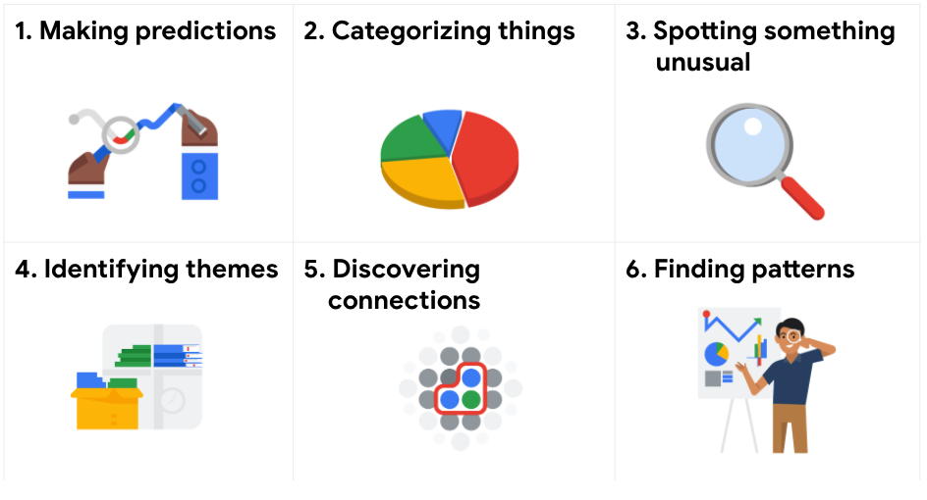

Making predictions
A company that wants to know the best advertising method to bring in new customers is an example of a problem requiring analysts to make predictions. Analysts with data on location, type of media, and number of new customers acquired as a result of past ads can't guarantee future results, but they can help predict the best placement of advertising to reach the target audience.

Categorizing things
This means assigning information to different groups or clusters based on common features.
An example of a problem requiring analysts to categorize things is a company's goal to improve customer satisfaction. Analysts might classify customer service calls based on certain keywords or scores. This could help identify top-performing customer service representatives or help correlate certain actions taken with higher customer satisfaction scores.

Spotting something unusual
This means assigning information to different groups or clusters based on common features.
A company that sells smart watches that help people monitor their health would be interested in designing their software to spot something unusual. Analysts who have analyzed aggregated health data can help product developers determine the right algorithms to spot and set off alarms when certain data doesn't trend normally.

Identifying themes
Recognizing broader concepts and trends from catergorized data.
Identifying themes takes categorization as a step further by grouping information into broader concepts.
User experience (UX) designers might rely on analysts to analyze user interaction data. Similar to problems that require analysts to categorize things, usability improvement projects might require analysts to identify themes to help prioritize the right product features for improvement. Themes are most often used to help researchers explore certain aspects of data. In a user study, user beliefs, practices, and needs are examples of themes.
By now you might be wondering if there is a difference between categorizing things and identifying themes. The best way to think about it is: categorizing things involves assigning items to categories; identifying themes takes those categories a step further by grouping them into broader themes.

Discovering connections
the problem type of discovering connections enables data analysts to find similar challenges faced by different entities, and then combine data and insights to address them
A third-party logistics company working with another company to get shipments delivered to customers on time is a problem requiring analysts to discover connections. By analyzing the wait times at shipping hubs, analysts can determine the appropriate schedule changes to increase the number of on-time deliveries.

Finding patterns
Data analysts use data to find patterns by using historical data to understand what happened in the past and is therefore likely to happen again.
Minimizing downtime caused by machine failure is an example of a problem requiring analysts to find patterns in data. For example, by analyzing maintenance data, they might discover that most failures happen if regular maintenance is delayed by more than a 15-day window.

SMART questions

Things to avoid when asking questions
Leading questions: questions that only have a particular response
Closed-ended questions: questions that ask for a one-word or brief response only
Vague questions: questions that aren’t specific or don’t provide context

SMART:
Specific: simple, significant, and focused on a single topic or a few closely related ideas
Measurable: can be qualified and accessed:
In the SMART methodology, measurable questions can be quantified and assessed. This might include a 1-to-5 scale or questions with yes-or-no responses.

Action-oriented: encourage change
Relevant: matter, are important and have significance to the problem you are trying to solve
Time-bound: specify the time to be studied 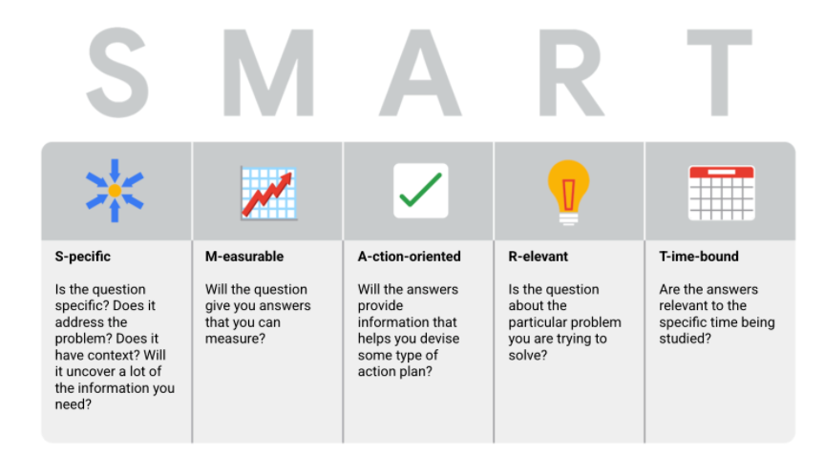

Data-driven decision making: accurate interpretation of data is key to data-driven decisions

Data-inspired decision making: explores different data sources to find out what they have in common (commonalities)

Algorithm: In data analytics, a process or set of rules to be followed for a specific task

Qualitative data:
qualitative data describes subjective or explanatory measures of qualities and characteristics or things that can't be measured with numerical data => Why questions

Quantitative data: Quantitative data is all about the specific and objective measures of numerical facts. => How many, How often
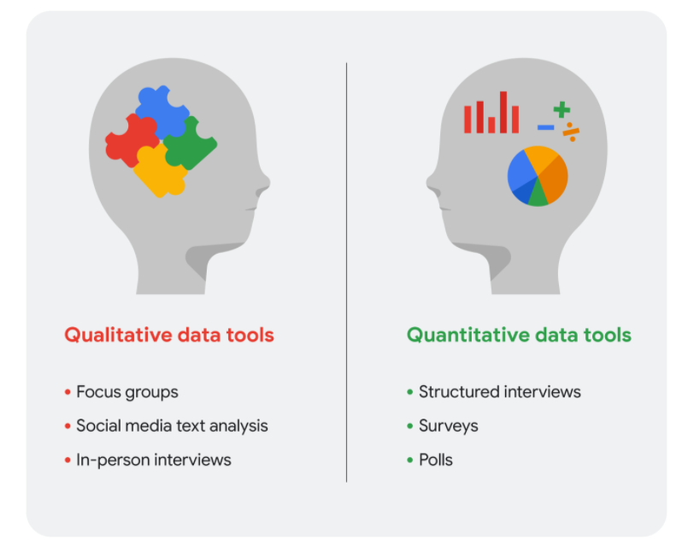

Data visualization:

Report: static collection of data given to stakeholders periodically, data never change
Reports are great for giving snapshots of high level historical data for an organization
Pros: high-level historical data, easy to design, pre-cleaned and sorted data
Cons: continual maintenance, less visually appealing, static
Pivot table:
A data summarization tool that is used in data processing. Pivot tables are used to summarize sort, reorganize, group, count, total or average data sorted in a database. (group data 分类数据)

Dashboard: monitors live and incoming data
Dashboards are visualizations: Visualizing data can be enormously useful for understanding and demonstrating what the data really means.
Dashboards identify metrics: Relevant metrics may help analysts assess company performance.

A dashboard organizes information from multiple datasets into one central location, offering huge time-savings.
Pros: dynamic automatic and interactive, more stakeholder access, low maintenance
Cons: labor-intensive design, can be confusing, potentially uncleaned data

Data versus metrics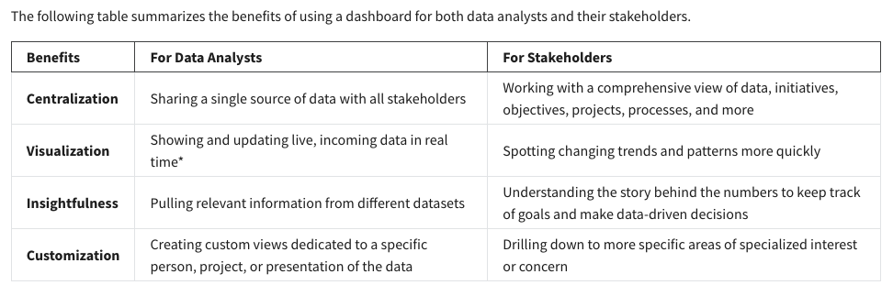
* It is important to remember that changed data is pulled into dashboards automatically only if the data structure is the same. If the data structure changes, you have to update the dashboard design before the data can update live.

Here is a process you can follow to create a dashboard:
1. Identify the stakeholders who need to see the data and how they will use it
To get started with this, you need to ask effective questions. Check out this Requirements Gathering Worksheet to explore a wide range of good questions you can use to identify relevant stakeholders and their data needs. This is a great resource to help guide you through this process again and again.
2. Design the dashboard (what should be displayed)
Use these tips to help make your dashboard design clear, easy to follow, and simple:
- Use a clear header to label the information
- Add short text descriptions to each visualization
- Show the most important information at the top

3. Create mock-ups if desired
This is optional, but a lot of data analysts like to sketch out their dashboards before creating them.
4. Select the visualizations you will use on the dashboard
You have a lot of options here and it all depends on what data story you are telling. If you need to show a change of values over time, line charts or bar graphs might be the best choice. If your goal is to show how each part contributes to the whole amount being reported, a pie or donut chart is probably a better choice.
5. Create filters as needed
Filters show certain data while hiding the rest of the data in a dashboard. This can be a big help to identify patterns while keeping the original data intact. It is common for data analysts to use and share the same dashboard, but manage their part of it with a filter. To dig deeper into filters and find an example of filters in action, you can visit Tableau’s page on Filter Actions. This is a useful resource to save and come back to when you start practicing using filters in Tableau on your own.

Dashboards are part of a business journey
Just like how the dashboard on an airplane shows the pilot their flight path, your dashboard does the same for your stakeholders. It helps them navigate the path of the project inside the data. If you add clear markers and highlight important points on your dashboard, users will understand where your data story is headed. Then, you can work together to make sure the business gets where it needs to go.
For a refresher, consider the different types of dashboards a business may use. Often, businesses will tailor a dashboard for a specific purpose. The three most common categories are:
- Strategic: focuses on long term goals and strategies at the highest level of metrics
A wide range of businesses use strategic dashboards when evaluating and aligning their strategic goals. These dashboards provide information over the longest time frame—from a single financial quarter to years. They typically contain information that is useful for enterprise-wide decision-making.

- Operational: short-term performance tracking and intermediate goals
Operational dashboards are, arguably, the most common type of dashboard. Because these dashboards contain information on a time scale of days, weeks, or months, they can provide performance insight almost in real-time. This allows businesses to track and maintain their immediate operational processes in light of their strategic goals.

- Analytical: consists of the datasets and the mathematics used in these sets
Analytic dashboards contain a vast amount of data used by data analysts. These dashboards contain the details involved in the usage, analysis, and predictions made by data scientists. Certainly the most technical category, analytic dashboards are usually created and maintained by data science teams and rarely shared with upper management as they can be very difficult to understand.

- Track historical and current performance.
- Establish both long-term and/or short-term goals.
- Define key performance indicators or metrics.
- Identify potential issues or points of inefficiency.
While almost every company can benefit in some way from using a dashboard, larger companies and companies with a wider range of products or services will likely benefit more. Companies operating in volatile, or swiftly changing markets like marketing, sales, and tech also tend to more quickly gain insights and make data-informed decisions.

Metric: single, quantifiable type of data that can be used for measurement.
Metrics are quantifiable data types used for measurement.
For example, metrics can be used to help calculate customer retention rates,
or a company's ability to keep its customers over time.

Data starts as a collection of raw facts, until we organize them into individual metrics that represent a single type of data. Metrics can also be combined into formulas that you can plug your numerical data into.

Different industries use all kinds of different metrics. But there's one thing they all have in common: they're all trying to meet a specific goal by measuring data.

Return on Investment (ROI) = Profit/Investment.

Mathematical thinking
Using a mathematical approach means looking at a problem and logically breaking it down step-by-step, so you can see the relationship of patterns in your data, and use that to analyze your problem. This kind of thinking can also help you figure out the best tools for analysis because it lets us see the different aspects of a problem and
choose the best logical approach
A metric is a single, quantifiable type of data used when setting and evaluating goals.

Small data:
Specific, short time-period, day-to-day decisions

Big data:
Large and less specific, long time-period
They usually have to be broken down to be analyzed. Big data is useful for looking at large- scale questions and problems, and they help companies make big decisions.
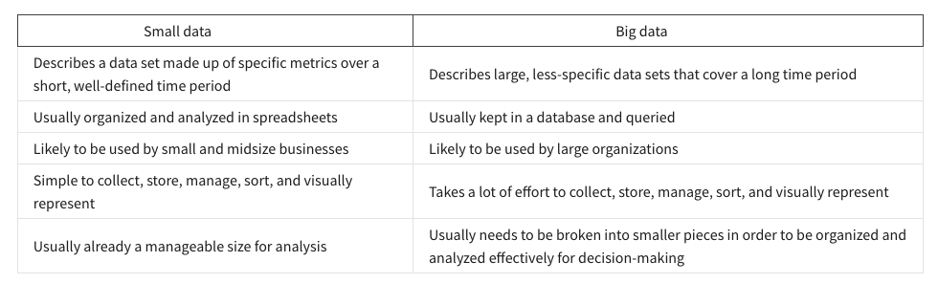

Here are some challenges you might face when working with big data:
- A lot of organizations deal with data overload and way too much unimportant or irrelevant information.
- Important data can be hidden deep down with all of the non-important data, which makes it harder to find and use. This can lead to slower and more inefficient decision-making time frames.
- The data you need isn’t always easily accessible.
- Current technology tools and solutions still struggle to provide measurable and reportable data. This can lead to unfair algorithmic bias.
- There are gaps in many big data business solutions.
Now for the good news! Here are some benefits that come with big data:
- When large amounts of data can be stored and analyzed, it can help companies identify more efficient ways of doing business and save a lot of time and money.
- Big data helps organizations spot the trends of customer buying patterns and satisfaction levels, which can help them create new products and solutions that will make customers happy.
- By analyzing big data, businesses get a much better understanding of current market conditions, which can help them stay ahead of the competition.
- As in our earlier social media example, big data helps companies keep track of their online presence—especially feedback, both good and bad, from customers. This gives them the information they need to improve and protect their brand.

The three (or four) V words for big data
When thinking about the benefits and challenges of big data, it helps to think about the three Vs: volume, variety, and velocity. Volume describes the amount of data. Variety describes the different kinds of data. Velocity describes how fast the data can be processed. Some data analysts also consider a fourth V: veracity. Veracity refers to the quality and reliability of the data. These are all important considerations related to processing huge, complex data sets.
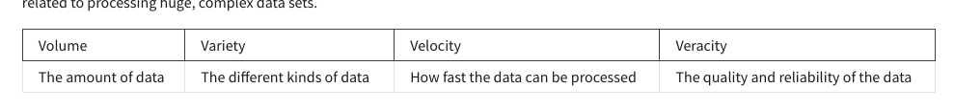

Spreadsheet:
The first steps a data analyst takes when working with data in a spreadsheet are to sort and filter the data.
Organize your data -> Pivot table => Sort and filter
Calculate your data -> Formulas, functions

- Plan for the users who will work within a spreadsheet by developing organizational standards. This can mean formatting your cells, the headings you choose to highlight, the color scheme, and the way you order your data points. When you take the time to set these standards, you will improve communication, ensure consistency, and help people be more efficient with their time.
- Capture data by the source by connecting spreadsheets to other data sources, such as an online survey application or a database. This data will automatically be updated in the spreadsheet. That way, the information is always as current and accurate as possible.
- Manage different kinds of data with a spreadsheet. This can involve storing, organizing, filtering, and updating information. Spreadsheets also let you decide who can access the data, how the information is shared, and how to keep your data safe and secure.
- Analyze data in a spreadsheet to help make better decisions. Some of the most common spreadsheet analysis tools include formulas to aggregate data or create reports, and pivot tables for clear, easy-to-understand visuals.
- Archive any spreadsheet that you don’t use often, but might need to reference later with built-in tools. This is especially useful if you want to store historical data before it gets updated.
- Destroy your spreadsheet when you are certain that you will never need it again, if you have better backup copies, or for legal or security reasons. Keep in mind, lots of businesses are required to follow certain rules or have measures in place to make sure data is destroyed properly.

Data analysts use formulas and functions to save time and effort by automating commands

Cell reference: a cell or a range of cells in a worksheet that can be used in a formula
(Automatically update)

Absolute referencing
- Absolute referencing is marked by a dollar sign ($). For example, =$A$10 has absolute referencing for both the column and the row value
- Relative references (which is what you normally do e.g. “=A10”) will change anytime the formula is copied and pasted. They are in relation to where the referenced cell is located. For example if you copied “=A10” to the cell to the right it would become “=B10”. With absolute referencing “=$A$10” copied to the cell to the right would remain “=$A$10”. But if you copied $A10 to the cell below, it would change to $A11 because the row value isn't an absolute reference.
- Absolute references will not change when you copy and paste the formula in a different cell. The cell being referenced is always the same.
- To easily switch between absolute and relative referencing in the formula bar, highlight the reference you want to change and press the F4 key; for example, if you want to change the absolute reference, $A$10, in your formula to a relative reference, A10, highlight $A$10 in the formula bar and then press the F4 key to make the change.

Data range
- When you click into your formula, the colored ranges let you see which cells are being used in your spreadsheet. There are different colors for each unique range in your formula.
- In a lot of spreadsheet applications, you can press the F2 (or Enter) key to highlight the range of data in the spreadsheet that is referenced in a formula. Click the cell with the formula, and then press the F2 (or Enter) key to highlight the data in your spreadsheet.

Combining with functions
- COUNTIF() is a formula and a function. This means the function runs based on criteria set by the formula. In this case, COUNT is the formula; it will be executed IF the conditions you create are true. For example, you could use =COUNTIF(A1:A16, “7”) to count only the cells that contained the number 7. Combining formulas and functions allows you to do more work with a single command.

# DIV/0: a formula is trying to divide a value in a cell by 0 or by an empty cell
#ERROR!: a formula cannot be interpreted as input (also known as a parsing error)
#N/A: Data in a formula cannot be found by the spreadsheet
#NAME?: a formula or function name isn’t understood
#NUM!: a formula or function calculation cannot be performed as specific
#VALUE!: a general error that could indicate a problem with a formula or refenced cell
#REF!: a formula is referencing a cell that is no longer valid or has been deleted
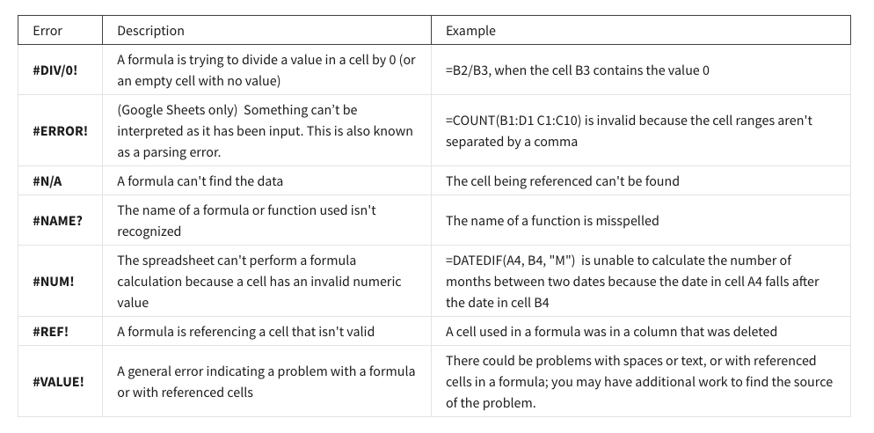

Conditional formatting in Microsoft Excel
To set up conditional formatting in Microsoft Excel to highlight all cells in a spreadsheet that contain errors, do the following:
- Click the gray triangle above row number 1 and to the left of Column A to select all cells in the spreadsheet.
- From the main menu, click Home, and then click Conditional Formatting to select Highlight Cell Rules > More Rules.
- For Select a Rule Type, choose Use a formula to determine which cells to format.
- For Format values where this formula is true, enter =ISERROR(A1).
- Click the Format button, select the Fill tab, select yellow (or any other color), and then click OK.
- Click OK to close the format rule window.
To remove conditional formatting, click Home and select Conditional Formatting, and then click Manage Rules. Locate the format rule in the list, click Delete Rule, and then click OK.

Conditional formatting in Google Sheets
To set up conditional formatting in Google Sheets to highlight all cells in a spreadsheet that contain errors, do the following:
- Click the empty rectangle above row number 1 and to the left of Column A to select all cells in the spreadsheet. In the Step-by-step in spreadsheets video, this was called the Select All button.
- From the main menu, click Format and select Conditional Formatting to open the Conditional format rules pane on the right.
- While in the Single Color tab, under Format rules, use the drop-down to select Custom formula is, enter =ISERROR(A1), select yellow (or any other color) for the formatting style, and then click Done.
To remove conditional formatting, click Format and select Conditional Formatting, and then click the Trash icon for the format rule.

Difference between formulas and functions
- A formula is a set of instructions used to perform a calculation using the data in a spreadsheet.
- A function is a preset command that automatically performs a specific process or task using the data in a spreadsheet.

Relative, absolute, and mixed references
- Relative references (cells referenced without a dollar sign, like A2) will change when you copy and paste the function into a different cell. With relative references, the location of the cell that contains the function determines the cells used by the function.
- Absolute references (cells fully referenced with a dollar sign, like $A$2) will not change when you copy and paste the function into a different cell. With absolute references, the cells referenced always remain the same.
- Mixed references (cells partially referenced with a dollar sign, like $A2 or A$2) will change when you copy and paste the function into a different cell. With mixed references, the location of the cell that contains the function determines the cells used by the function, but only the row or column is relative (not both).
- In spreadsheets, you can press the F4 key to toggle between relative, absolute, and mixed references in a function. Click the cell containing the function, highlight the referenced cells in the formula bar, and then press F4 to toggle between and select relative, absolute, or mixed referencing.

Data ranges
- When you click a cell that contains a function, colored data ranges in the formula bar indicate which cells are being used in the spreadsheet. There are different colors for each unique range in a function.
- Colored data ranges help prevent you from getting lost in complex functions.
- In spreadsheets, you can press the F2 key to highlight the range of data used by a function. Click the cell containing the function, highlight the range of data used by the function in the formula bar, and then press F2. The spreadsheet will go to and highlight the cells specified by the range.

The COUNTIF function quickly counts how many items in a range of cells meet a given criterion.

Structured thinking:
Structured thinking is the process of recognizing the current problem or situation,
organizing available information, revealing gaps and opportunities, and identifying the options.
(No implementing a solution)

Problem domain:
The starting /specific place of analysis that encompasses every activity affecting or affected by the problem.

Scope of Work (SOW):
An agreed-upon outline of the work you are going to perform on a project.
(work details, schedules,.)
- Deliverables: are items or tasks you will complete before you can finish the project.
What work is being done, and what things are being created as a result of this project? When the project is complete, what are you expected to deliver to the stakeholders? Be specific here. Will you collect data for this project? How much, or for how long?

- Timeline: include due dates for when deliverables, milestones, and/or reports are due.
Your timeline will be closely tied to the milestones you create for your project. The timeline is a way of mapping expectations for how long each step of the process should take. The timeline should be specific enough to help all involved decide if a project is on schedule. When will the deliverables be completed? How long do you expect the project will take to complete? If all goes as planned, how long do you expect each component of the project will take? When can we expect to reach each milestone?

- Milestones: Milestones are significant tasks you will confirm along your timeline to help everyone know the project is on track.
This is closely related to your timeline. What are the major milestones for progress in your project? How do you know when a given part of the project is considered complete?

- Report: notify everyone as you finalize deliverables and meet milestones.
Good SOWs also set boundaries for how and when you’ll give status updates to stakeholders. How will you communicate progress with stakeholders and sponsors, and how often? Will progress be reported weekly? Monthly? When milestones are completed? What information will status reports contain?

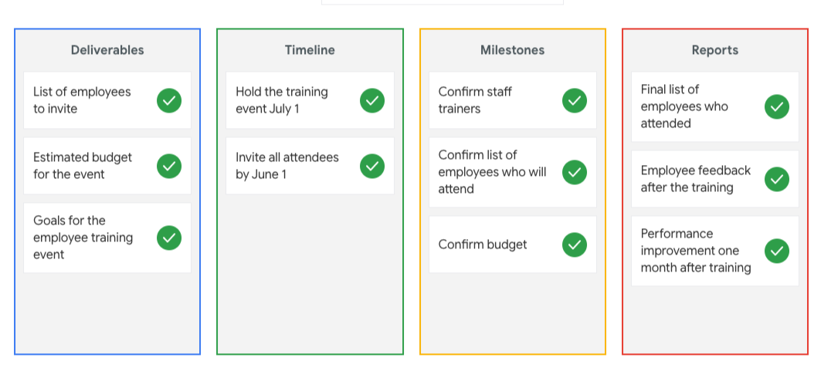

A statement of work is a document that clearly identifies the products and services a vendor or contractor will provide to an organization. It includes objectives, guidelines, deliverables, schedule, and costs.
A scope of work is project-based and sets the expectations and boundaries of a project. A scope of work may be included in a statement of work to help define project outcomes.

Context:
The condition in which something exists or happens.

Context can turn raw data into meaningful information.

A data analyst asks who, what, when, where, why, and how in order to put information into context.
- Who: The person or organization that created, collected, and/or funded the data collection
- What: The things in the world that data could have an impact on
- Where: The origin of the data
- When: The time when the data was created or collected
- Why: The motivation behind the creation or collection
- How: The method used to create or collect it

Stakeholder:
People that have invested time, interest, and resources into the projects you will be working on as a data analyst.

three common stakeholder groups that you might find yourself working with: the executive team, the customer-facing team, and the data science team.

Executive team
The executive team provides strategic and operational leadership to the company. They set goals, develop strategy, and make sure that strategy is executed effectively. The executive team might include vice presidents, the chief marketing officer, and senior-level professionals who help plan and direct the company’s work. These stakeholders think about decisions at a very high level and they are looking for the headline news about your project first. They are less interested in the details. Time is very limited with them, so make the most of it by leading your presentations with the answers to their questions. You can keep the more detailed information handy in your presentation appendix or your project documentation for them to dig into when they have more time.

Customer-facing team
The customer-facing team includes anyone in an organization who has some level of interaction with customers and potential customers. Typically they compile information, set expectations, and communicate customer feedback to other parts of the internal organization. These stakeholders have their own objectives and may come to you with specific asks. It is important to let the data tell the story and not be swayed by asks from your stakeholders to find certain patterns that might not exist.

Data science team
Organizing data within a company takes teamwork. There's a good chance you'll find yourself working with other data analysts, data scientists, and data engineers. Here's a view of how different roles on a typical data science team support different functions:
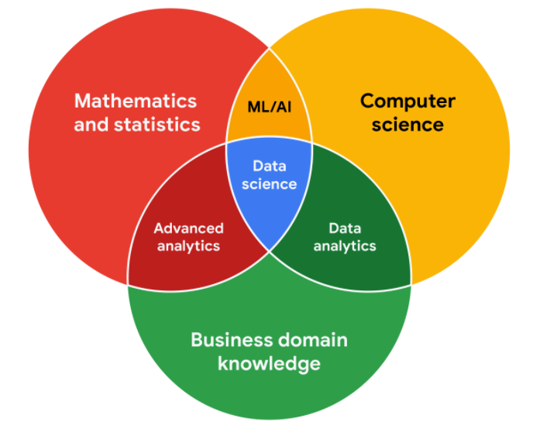
Turnover rate:
The rate at which employees leave the company.

Working effectively with stakeholders
Discuss goals. Stakeholder requests are often tied to a bigger project or goal. When they ask you for something, take the opportunity to learn more. Start a discussion. Ask about the kind of results the stakeholder wants. Sometimes, a quick chat about goals can help set expectations and plan the next steps.

Feel empowered to say “no.” Let’s say you are approached by a marketing director who has a “high-priority” project and needs data to back up their hypothesis. They ask you to produce the analysis and charts for a presentation by tomorrow morning. Maybe you realize their hypothesis isn’t fully formed and you have helpful ideas about a better way to approach the analysis. Or maybe you realize it will take more time and effort to perform the analysis than estimated. Whatever the case may be, don’t be afraid to push back when you need to.

Plan for the unexpected. Before you start a project, make a list of potential roadblocks. Then, when you discuss project expectations and timelines with your stakeholders, give yourself some extra time for problem-solving at each stage of the process.

Know your project. Keep track of your discussions about the project over email or reports, and be ready to answer questions about how certain aspects are important for your organization. Get to know how your project connects to the rest of the company and get involved in providing the most insight possible. If you have a good understanding about why you are doing an analysis, it can help you connect your work with other goals and be more effective at solving larger problems.
Start with words and visuals. It is common for data analysts and stakeholders to interpret things in different ways while assuming the other is on the same page. This illusion of agreement* has been historically identified as a cause of projects going back-and-forth a number of times before a direction is finally nailed down. To help avoid this, start with a description and a quick visual of what you are trying to convey. Stakeholders have many points of view and may prefer to absorb information in words or pictures. Work with them to make changes and improvements from there. The faster everyone agrees, the faster you can perform the first analysis to test the usefulness of the project, measure the feedback, learn from the data, and implement changes.
Communicate often. Your stakeholders will want regular updates on your projects. Share notes about project milestones, setbacks, and changes. Then use your notes to create a shareable report. Another great resource to use is a change-log, which you will learn more throughout the program. For now, just know that a change-log is a file containing a chronologically ordered list of modifications made to a project. Depending on the way you set it up, stakeholders can even pop in and view updates.

Three things focusing on that will help staying on task :
- Who are the primary and secondary stakeholders?
  - Take time at the beginning of every project to identify your stakeholders and their goals. Then see who else is on your team and what their roles are.
- Who is managing the data?
  - If you hadn't communicated with this person, you might have spent a lot of time trying to collect or analyze hiring data yourself or you may not have even been able to include it in your analysis at all. Instead, you were able to communicate your objectives with another data analyst and use existing work to make your analysis richer. By understanding who's managing the data, you can spend your time more productively.
- Where can you go for help?
  - This is something you should know at the beginning of any project you work on. When you know who's able to help, you'll spend less time worrying about other aspects of the project and more time focused on the objective.

Clear/ effective communication
Before you communicate:
  - Who your audience is
  - What they already know
  - What they need to know
  - How you can communicate that effectively to them

Limitation of data:
- The case of incomplete data:
If you have incomplete or nonexistent data, you might realize during an analysis that you don't have enough data to reach a conclusion. Or, you might even be solving a different problem altogether!
- Don’t miss misaligned data
If you're collecting data from other teams and using existing spreadsheets, it is good to keep in mind that people use different business rules. So one team might define and measure things in a completely different way than another.
- Deal with dirty data
Dirty data refers to data that contains errors. Dirty data can lead to productivity loss, unnecessary spending, and unwise decision-making. A good data cleaning effort can help you avoid this. As a quick reminder, data cleaning is the process of fixing or removing incorrect, corrupted, incorrectly formatted, duplicate, or incomplete data within a dataset. When you find and fix the errors - while tracking the changes you made - you can avoid a data disaster. You will learn how to clean data later in the training.
- Tell a clear story
- Compare the same types of data: Data can get mixed up when you chart it for visualization. Be sure to compare the same types of data and double check that any segments in your chart definitely display different metrics.
- Visualize with care: A 0.01% drop in a score can look huge if you zoom in close enough. To make sure your audience sees the full story clearly, it is a good idea to set your Y-axis to 0.
- Leave out needless graphs: If a table can show your story at a glance, stick with the table instead of a pie chart or a graph. Your busy audience will appreciate the clarity.
- Test for statistical significance: Sometimes two datasets will look different, but you will need a way to test whether the difference is real and important. So remember to run statistical tests to see how much confidence you can place in that difference.
- Pay attention to sample size: Gather lots of data. If a sample size is small, a few unusual responses can skew the results. If you find that you have too little data, be careful about using it to form judgments. Look for opportunities to collect more data, then chart those trends over longer periods.
- Be the judge
In any organization, a big part of a data analyst’s role is making sound judgments. When you know the limitations of your data, you can make judgment calls that help people make better decisions supported by the data.

Leading great meetings

Before the meeting
If you are organizing the meeting, you will probably talk about the data. Before the meeting:
- Identify your objective. Establish the purpose, goals, and desired outcomes of the meeting, including any questions or requests that need to be addressed.
- Acknowledge participants and keep them involved with different points of view and experiences with the data, the project, or the business.
- Organize the data to be presented. You might need to turn raw data into accessible formats or create data visualizations.
- Prepare and distribute an agenda. We will go over this next.

Crafting a compelling agenda
A solid meeting agenda sets your meeting up for success. Here are the basic parts your agenda should include:
- Meeting start and end time
- Meeting location (including information to participate remotely, if that option is available)
- Objectives
- Background material or data the participants should review beforehand
Here's an example of an agenda for an analysis project that is just getting started:

Sharing your agenda ahead of time
After writing your agenda, it's time to share it with the invitees. Sharing the agenda with everyone ahead of time helps them understand the meeting goals and prepare questions, comments, or feedback. You can email the agenda or share it using another collaboration tool.

During the meeting
As the leader of the meeting, it's your job to guide the data discussion. With everyone well informed of the meeting plan and goals, you can follow these steps to avoid any distractions:
- Make introductions (if necessary) and review key messages
- Present the data
- Discuss observations, interpretations, and implications of the data
- Take notes during the meeting
- Determine and summarize next steps for the group

After the meeting
To keep the project and everyone aligned, prepare and distribute a brief recap of the meeting with next steps that were agreed upon in the meeting. You can even take it a step further by asking for feedback from the team.
- Distribute any notes or data
- Confirm next steps and timeline for additional actions
- Ask for feedback (this is an effective way to figure out if you missed anything in your recap)

A final word about meetings
Even with the most careful planning and detailed agendas, meetings can sometimes go off track. An emergency situation might steal people’s attention. A recent decision might unexpectedly change requirements that were previously discussed and agreed on. Action items might not apply to the current situation. If this happens, you might be forced to shorten or cancel your meeting. That's all right; just be sure to discuss anything that impacts your project with your manager or stakeholders and reschedule your meeting after you have more information.

Question 5
To make sure that a few unusual responses don’t skew results or lead to inaccurate judgements, a data analyst focuses on what element of the data collection?
Sample Size

stakeholders are people who invest time, interest, and resources into the projects you’ll be working on as a data analyst. Secondary stakeholders are also typically responsible for managing the data.

Course 3: Prepare Data for Exploration
To track people's online activities and interests, cookies are most effective.

First-party data
- Data collected by an individual or group using their own resources

Second-party data
- Data collected by a group directly from its audience and then sold

Third-party data
- Data collected from outside sources who did not correct it directly

Data collection consideration
- How the data will be collected
- Choose data sources
- Decide what data to use
- How much data to collect
- Select the right data type
- Determine the time frame

Solving your business problem
Datasets can show a lot of interesting information. But be sure to choose data that can actually help solve your problem question. For example, if you are analyzing trends over time, make sure you use time series data — in other words, data that includes dates.

How much data to collect
If you are collecting your own data, make reasonable decisions about sample size. A random sample from existing data might be fine for some projects. Other projects might need more strategic data collection to focus on certain criteria. Each project has its own needs.

Time frame
If you are collecting your own data, decide how long you will need to collect it, especially if you are tracking trends over a long period of time. If you need an immediate answer, you might not have time to collect new data. In this case, you would need to use historical data that already exists.
Observation is the method of data-collection most often used by scientists.
In data analytics, a population refers to all possible data values in a certain dataset.

Discrete data
- Data that is counted and has a limited number of values

Continuous data
- Data that is measured and can have almost any numeric value

Nominal data
- A type of qualitative data that is categorized without a set order

Ordinal data
- A type of qualitative data with a set order or scale

Internal data
- Data that lives within a company's own systems

External data
- Data that lives and is generated outside of an organization

Structured data
- Data organized in a certain format such as rows and columns
- Structured data that is grouped together to form relations enables analysts to more easily store, search, and analyze the data.

Unstructured data
- Data that is not organized in any easily identifiable manner

The star rating is an example of ordinal data because the number of stars are in order of how much each person liked the movie. It’s also an example of discrete data because a person has to choose a full star measure; half-stars weren’t an option.

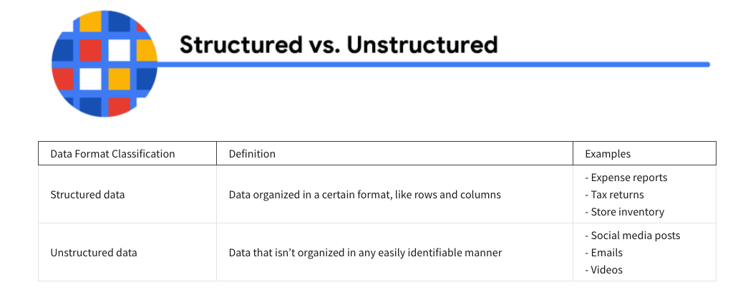

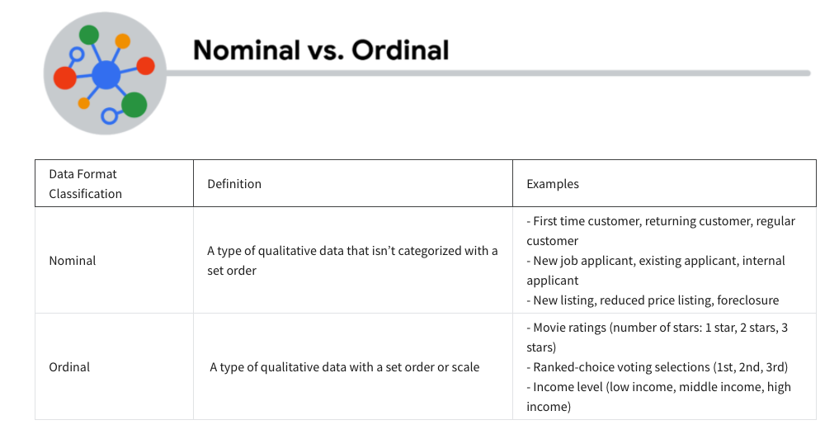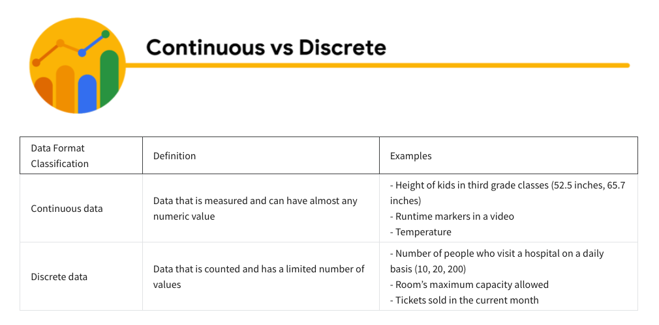
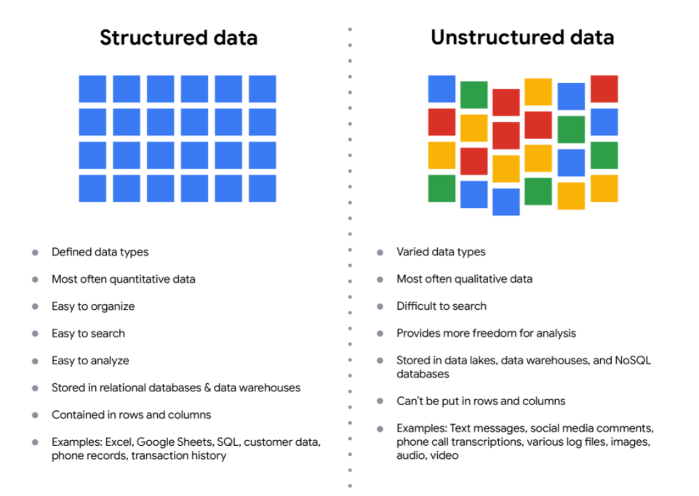
Unstructured data is not organized, although it may have an internal structure.

The fairness issue
The lack of structure makes unstructured data difficult to search, manage, and analyze. But recent advancements in artificial intelligence and machine learning algorithms are beginning to change that. Now, the new challenge facing data scientists is making sure these tools are inclusive and unbiased. Otherwise, certain elements of a dataset will be more heavily weighted and/or represented than others. And as you're learning, an unfair dataset does not accurately represent the population, causing skewed outcomes, low accuracy levels, and unreliable analysis.

Data model
- A model that is used for organizing data elements and how they relate to one another
- Data modeling is the process of creating diagrams that visually represent how data is organized and structured. These visual representations are called data models

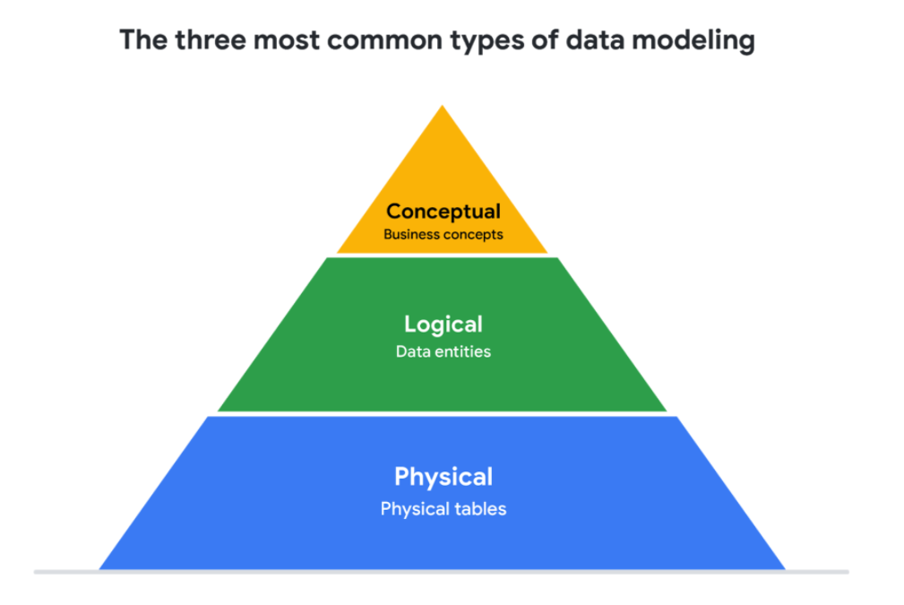
- Conceptual data modeling gives a high-level view of the data structure, such as how data interacts across an organization. For example, a conceptual data model may be used to define the business requirements for a new database. A conceptual data model doesn't contain technical details.
- Logical data modeling focuses on the technical details of a database such as relationships, attributes, and entities. For example, a logical data model defines how individual records are uniquely identified in a database. But it doesn't spell out actual names of database tables. That's the job of a physical data model.
- Physical data modeling depicts how a database operates. A physical data model defines all entities and attributes used; for example, it includes table names, column names, and data types for the database.

Data-modeling techniques
There are a lot of approaches when it comes to developing data models, but two common methods are the Entity Relationship Diagram (ERD) and the Unified Modeling Language (UML) diagram. ERDs are a visual way to understand the relationship between entities in the data model. UML diagrams are very detailed diagrams that describe the structure of a system by showing the system's entities, attributes, operations, and their relationships. As a junior data analyst, you will need to understand that there are different data modeling techniques, but in practice, you will probably be using your organization’s existing technique.

Data analysis and data modeling
Data modeling can help you explore the high-level details of your data and how it is related across the organization’s information systems. Data modeling sometimes requires data analysis to understand how the data is put together; that way, you know how to map the data. And finally, data models make it easier for everyone in your organization to understand and collaborate with you on your data. This is important for you and everyone on your team!

Data elements
- Pieces of information, such as people's names, account numbers, and addresses

Boolean data: two possible values, Yes or No
The Boolean operator OR expands the number of results when used in a keyword search.

Boolean logic

Data analysts refer to the data contained in a column as a field.

Wide data
- Data in which every data subject has a single row with multiple columns to hold the values of various attributes of the subject

Long data
- Data in which each row is one time point per subject, so each subject will have data in multiple rows
In long data, separate columns contain the values and the context for the values, respectively. What does each column contain in wide data? A unique data variable

Transforming Data
Data transformation is the process of changing the data’s format, structure, or values. As a data analyst, there is a good chance you will need to transform data at some point to make it easier for you to analyze it.
Data transformation usually involves:
- Adding, copying, or replicating data
- Deleting fields or records
- Standardizing the names of variables
- Renaming, moving, or combining columns in a database
- Joining one set of data with another
- Saving a file in a different format. For example, saving a spreadsheet as a comma separated values (CSV) file.

Why transform data?
Goals for data transformation might be:
- Data organization: better organized data is easier to use
- Data compatibility: different applications or systems can then use the same data (Compatibility describes how well two or more datasets are able to work together.
- Data migration: data with matching formats can be moved from one system to another
- Data merging: data with the same organization can be merged together
- Data enhancement: data can be displayed with more detailed fields
- Data comparison: apples-to-apples comparisons of the data can then be made

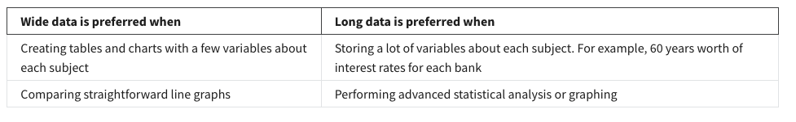

Data bias
- A type of error that systematically skews results in a certain direction

Sampling bias
- A sample that isn't representative of the population as a whole

Unbiased sampling
- A sample that's representative of the population being measured

More types of data bias
- Observer bias (experimenter bias / research bias): The tendency for different people to observe things differently
- Interpretation bias: The tendency to always interpret ambiguous situations in a positive or negative way
- Confirmation bias: The tendency to search for or interpret information in a way that confirms pre-existing beliefs

Explore data credibility

Identifying good data sources - ROCCC
- Reliable
- Original
- Comprehensive
- Current
- Cited: Is this dataset from a credible organization?” and “Who created this dataset?” are questions that can help you determine if a data source is cited.

Data ethics refers
- Well- founded standards of right and wrong that dictate how data is collected, shared, and used.
GDPR - General Data Protection Regulation of the European Union

Aspects of data ethics
- Ownership - Individuals who own the raw data they provide, and they have primary control over its usage, how it's processed and how it's shared
- Transaction transparency - All data processing activities and algorithms should be completely explainable and understood by the individual who provides their data
- Consent - An individual's right to know explicit details about how and why their data will be used before agreeing to provide it
- Currency - Individuals should be aware of financial transactions resulting from the use of their personal data and the scale of these transactions
- Privacy - Preserving a data subject's information and activity any time a data transaction occurs
  - Protection from unauthorized access to our private data
  - Freedom from inappropriate use of our data
  - The right to inspect, update, or correct our data
  - Ability to give consent to use our data
  - Legal right to access our data.
- Openness (or open data) - Free access, usage, and sharing of data

Data anonymization

What is data anonymization?
Personally identifiable information, or PII, is information that can be used by itself or with other data to track down a person's identity. Data anonymization applies to all personally identifiable information, including text and images.

Data anonymization is the process of protecting people's private or sensitive data by eliminating that kind of information. Typically, data anonymization involves blanking, hashing, or masking personal information, often by using fixed-length codes to represent data columns, or hiding data with altered values.

Your role in data anonymization
Organizations have a responsibility to protect their data and the personal information that data might contain. As a data analyst, you might be expected to understand what data needs to be anonymized, but you generally wouldn't be responsible for the data anonymization itself. A rare exception might be if you work with a copy of the data for testing or development purposes. In this case, you could be required to anonymize the data before you work with it.

What types of data should be anonymized?
Healthcare and financial data are two of the most sensitive types of data. These industries rely a lot on data anonymization techniques. After all, the stakes are very high. That’s why data in these two industries usually goes through de-identification, which is a process used to wipe data clean of all personally identifying information.
Data anonymization is used in just about every industry. That is why it is so important for data analysts to understand the basics. Here is a list of data that is often anonymized:
- Telephone numbers
- Names
- License plates and license numbers
- Social security numbers
- IP addresses
- Medical records
- Email addresses
- Photographs
- Account numbers
Interoperability is key to open data's success.
In data analytics, open data is part of data ethics, which has to do with using data ethically. Openness refers to free access, usage, and sharing of data. But for data to be considered open, it has to:
- Be available and accessible to the public as a complete dataset
- Be provided under terms that allow it to be reused and redistributed
- Allow universal participation so that anyone can use, reuse, and redistribute the data
Data can only be considered open when it meets all three of these standards.

The open data debate: What data should be publicly available?
One of the biggest benefits of open data is that credible databases can be used more widely. Basically, this means that all of that good data can be leveraged, shared, and combined with other data. This could have a huge impact on scientific collaboration, research advances, analytical capacity, and decision-making. But it is important to think about the individuals being represented by the public, open data, too.
Third-party data is collected by an entity that doesn’t have a direct relationship with the data. You might remember learning about this type of data earlier. For example, third parties might collect information about visitors to a certain website. Doing this lets these third parties create audience profiles, which helps them better understand user behavior and target them with more effective advertising.
Personal identifiable information (PII) is data that is reasonably likely to identify a person and make information known about them. It is important to keep this data safe. PII can include a person’s address, credit card information, social security number, medical records, and more.
Everyone wants to keep personal information about themselves private. Because third-party data is readily available, it is important to balance the openness of data with the privacy of individuals.

Database

Metadata: data about data
Normalized database
- A database in which only related data is stored in each table
- A key benefit of working with normalized databases is that they help lower data redundancy.
Redundancy
- When the same piece of data is stored in two or more separate places
Schema
- A way of describing how something is organized

Relational databases
A relational database is a database that contains a series of tables that can be connected to show relationships. Basically, they allow data analysts to organize and link data based on what the data has in common.
In a non-relational table, you will find all of the possible variables you might be interested in analyzing all grouped together. This can make it really hard to sort through. This is one reason why relational databases are so common in data analysis: they simplify a lot of analysis processes and make data easier to find and use across an entire database.
Primary Key:
An identifier that references a column in which each value is unique.
Primary keys are unique, and the value assigned to that key for each row can only exist once within a given table

Foreign key:
foreign key is a field within a table that is a primary key in another table

Both primary and foreign keys connect tables in relational databases. Tables can only have one primary key, but can have multiple foreign keys

A table can only have one primary key, but it can have multiple foreign keys.

Databases use a special language to communicate called a query language. Structured Query Language (SQL) is a type of query language that lets data analysts communicate with a database. So, a data analyst will use SQL to create a query to view the specific data that they want from within the larger set.

Metadata is used in database management to help data analysts interpret the contents of the data within the database.
3 common types of metadata
- Descriptive - Metadata that describes a piece of data and can be used to identify it at a later point in time
- Structural - Metadata that indicates how a piece of data is organized and whether it is part of one, or more than one, data collection. Structural metadata indicates exactly how many collections data lives in. It provides information about how a piece of data is organized and whether it’s part of one, or more than one, data collection.
- Administrative - Metadata that indicates the technical source of a digital asset. The date and time a photo was taken is an example of administrative metadata.

Metadata creates a single source of truth by keeping things consistent and uniform.
Metadata also makes data more reliable by making sure it's accurate, precise, relevant, and timely.
The company can use the metadata to standardize the data and evaluate the third-party data’s quality and credibility.

Metadata repositories
- Describe the state and location of the metadata
- Describe the structures of the tables inside
- Describe how the data flows through the repository
- Keep track of who accesses the metadata and when

Elements of metadata
Before looking at metadata examples, it is important to understand what type of information metadata typically provides.

Title and description
What is the name of the file or website you are examining? What type of content does it contain?

Tags and categories
What is the general overview of the data that you have? Is the data indexed or described in a specific way?

Who created it and when
Where did the data come from, and when was it created? Is it recent, or has it existed for a long time?

Who last modified it and when
Were any changes made to the data? If yes, were the modifications recent?

Who can access or update it
Is this dataset public? Are special permissions needed to customize or modify the dataset?

Examples of metadata
In today’s digital world, metadata is everywhere, and it is becoming a more common practice to provide metadata on a lot of media and information you interact with. Here are some real-world examples of where to find metadata:

Photos
Whenever a photo is captured with a camera, metadata such as camera filename, date, time, and geolocation are gathered and saved with it.

Emails
When an email is sent or received, there is lots of visible metadata such as subject line, the sender, the recipient and date and time sent. There is also hidden metadata that includes server names, IP addresses, HTML format, and software details.

Spreadsheets and documents
Spreadsheets and documents are already filled with a considerable amount of data so it is no surprise that metadata would also accompany them. Titles, author, creation date, number of pages, user comments as well as names of tabs, tables, and columns are all metadata that one can find in spreadsheets and documents.

Websites
Every web page has a number of standard metadata fields, such as tags and categories, site creator’s name, web page title and description, time of creation and any iconography.

Digital files
Usually, if you right click on any computer file, you will see its metadata. This could consist of file name, file size, date of creation and modification, and type of file.

Books
Metadata is not only digital. Every book has a number of standard metadata on the covers and inside that will inform you of its title, author’s name, a table of contents, publisher information, copyright description, index, and a brief description of the book’s contents.

Using a metadata repository, a data analyst can find it easier to bring together multiple sources of data, confirm how or when data was collected, and verify that data from an outside source is being used appropriately.

Data governance
A process to ensure the formal management of a company’s data assets.

CSV = Comma separated values
A CSV file saves data in a table format

CSV files use plain text and are delineated by characters, such as a comma. A delineator indicates a boundary or separation between two things.

A CSV file makes it easier for data analysts to examine a small part of a large dataset, import data to a new spreadsheet, and distinguish values from one another.

Sorting data:
Arranging data into a meaningful order to make it easier to understand, analyze and visualize

Filtering:
Showing only the data that meets a specific criteria while hiding the rest

BigQuery
Sandbox
Free trail

When writing a query, the name of the dataset can either be inside two backticks, or not, and the query will still run properly.

Best Practices when organizing data
- Naming conventions : Consistent guidelines that describe the content, date, or version of a file in its name
- Foldering: organizing your files into folders helps keep project-related files together in one place
- Archiving older files : You might then break that folder down even further by creating subfolders like itinerary or photos, depending on what else you'd like to easily access. It can also be useful to move old projects to a separate location to create an archive and cut down on clutter.
- Align your naming and storage practices with your team
- Develop metadata practices
Remember these tips for staying organized as you work with files:
- Create folders and subfolders in a logical hierarchy so related files are stored together.
- Separate ongoing from completed work so your current project files are easier to find. Archive older files in a separate folder, or in an external storage location.
- If your files aren't automatically backed up, manually back them up often to avoid losing important

File naming conventions:
Consistent guidelines that describes the content, data or version of a file in its name

File name format : yyyymmdd, short and sweet

Good file organization includes making it easy to find current, related files that are backed up regularly.

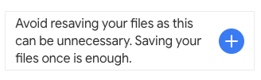 Wrong

To separate current from past work and reduce clutter, data analysts create archives.

Security features
Data security means protecting data from unauthorized access or corruption by putting safety measures in place.
Usually the purpose of data security is to keep unauthorized users from accessing or viewing sensitive data. Data analysts have to find a way to balance data security with their actual analysis needs. This can be tricky-- we want to keep our data safe and secure, but we also want to use it as soon as possible so that we can make meaningful and timely observations.
In order to do this, companies need to find ways to balance their data security measures with their data access needs.
Luckily, there are a few security measures that can help companies do just that. The two we will talk about here are encryption and tokenization.
Access control features

Encryption uses a unique algorithm to alter data and make it unusable by users and applications that don’t know the algorithm. This algorithm is saved as a “key” which can be used to reverse the encryption; so if you have the key, you can still use the data in its original form.
Tokenization replaces the data elements you want to protect with randomly generated data referred to as a “token.” The original data is stored in a separate location and mapped to the tokens. To access the complete original data, the user or application needs to have permission to use the tokenized data and the token mapping. This means that even if the tokenized data is hacked, the original data is still safe and secure in a separate location.
Data analysts use encryption and sharing permissions to control who can access or edit a spreadsheet.

Encryption and tokenization are just some of the data security options out there. There are a lot of others, like using authentication devices for AI technology.
As a junior data analyst, you probably won’t be responsible for building out these systems. A lot of companies have entire teams dedicated to data security or hire third party companies that specialize in data security to create these systems. But it is important to know that all companies have a responsibility to keep their data secure, and to understand some of the potential systems your future employer might use.

A professional online present can
- Help potential employers find you
- Make connections with other analysts
- Learn and share data findings
- Participate in community events

Mentor
A professional who shares their knowledge, skills, and experience to help you develop and grow.

Sponsor:
A professional advocate who’s committed to moving a sponsee’s career forward within an organization.

Course 4: Process Data from Dirty to Clean

A strong analysis depends on the integrity of the data.
Data integrity is the accuracy, completeness, consistency, and trustworthiness of data throughout its lifecycle.
- Data replication compromising data integrity

- Data transfer compromising data integrity

- Data manipulation compromising data integrity: makes data more organized and easier to read
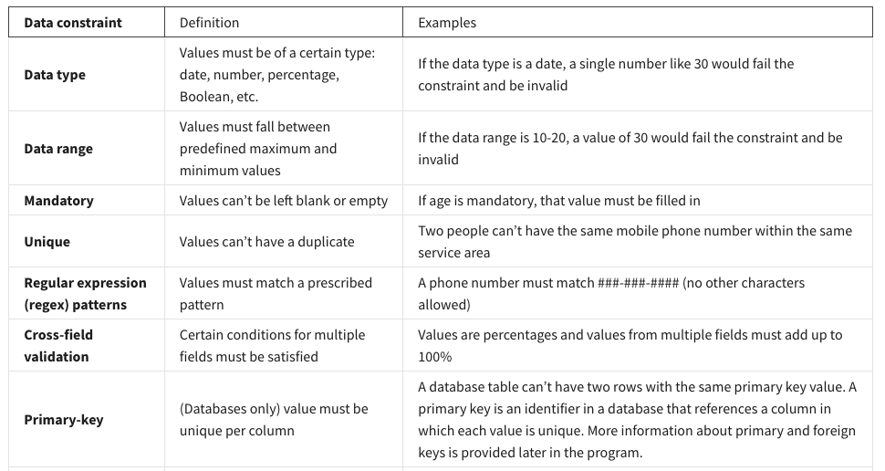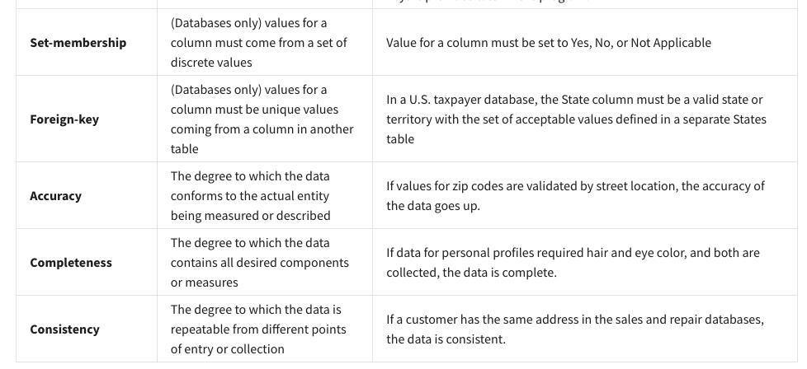

Clean data + alignment to business objective = accurate conclusions

Key takeaways
- When there is clean data and good alignment, you can get accurate insights and make conclusions the data supports.
- If there is good alignment but the data needs to be cleaned, clean the data before you perform your analysis.
- If the data only partially aligns with an objective, think about how you could modify the objective, or use data constraints to make sure that the subset of data better aligns with the business objective.

Type of insufficient data
- Data from only one source
- Data that keeps updating
- Outdated data
- Geographically-limited data

Ways to address insufficient data
- Identify trends with the available data
- Wait for more data if time allows
- Talk with stakeholders and adjust your objective
- Look for a new dataset
- If you have insufficient data, you can identify trends with the data that is available and qualify your findings accordingly.

Calculating sample size
Companies usually create sample sizes before data analysis so analysts know that the resulting dataset is representative of a population.

Margin of error | Since a sample is used to represent a population, the sample’s results are expected to differ from what the result would have been if you had surveyed the entire population. This difference is called the margin of error. The smaller the margin of error, the closer the results of the sample are to what the result would have been if you had surveyed the entire population.
Confidence level | How confident you are in the survey results. For example, a 95% confidence level means that if you were to run the same survey 100 times, you would get similar results 95 of those 100 times. Confidence level is targeted before you start your study because it will affect how big your margin of error is at the end of your study.
Confidence interval | The range of possible values that the population’s result would be at the confidence level of the study. This range is the sample result +/- the margin of error.
Statistical significance | The determination of whether your result could be due to random chance or not. The greater the significance, the less due to chance.

Things to remember when determining the size of your sample
When figuring out a sample size, here are things to keep in mind:
- Don’t use a sample size less than 30. It has been statistically proven that 30 is the smallest sample size where an average result of a sample starts to represent the average result of a population.
- The confidence level most commonly used is 95%, but 90% can work in some cases.
Increase the sample size to meet specific needs of your project:
- For a higher confidence level, use a larger sample size
- To decrease the margin of error, use a larger sample size
- For greater statistical significance, use a larger sample size

Why a minimum sample of 30?
This recommendation is based on the Central Limit Theorem (CLT) in the field of probability and statistics. As sample size increases, the results more closely resemble the normal (bell-shaped) distribution from a large number of samples. A sample of 30 is the smallest sample size for which the CLT is still valid. Researchers who rely on regression analysis – statistical methods to determine the relationships between controlled and dependent variables – also prefer a minimum sample of 30.
Statistical power
The probability of getting meaningful results from a test (0.6 → 60%)
Hypothesis testing
A way to see if a survey or experiment has meaningful results
Statistically significant
If a test is statistically significant, it means the results of the test are real and not an error caused by random chance.
Usually, you need a statistical power of at least 0.8 or 80% to consider your results statistically significant.

When there is no data, we can use the proxy data. Proxy data examples
Business scenario | How proxy data can be used
A new car model was just launched a few days ago and the auto dealership can’t wait until the end of the month for sales data to come in. They want sales projections now. | The analyst proxies the number of clicks to the car specifications on the dealership’s website as an estimate of potential sales at the dealership.
A brand new plant-based meat product was only recently stocked in grocery stores and the supplier needs to estimate the demand over the next four years. | The analyst proxies the sales data for a turkey substitute made out of tofu that has been on the market for several years.
The Chamber of Commerce wants to know how a tourism campaign is going to impact travel to their city, but the results from the campaign aren’t publicly available yet. | The analyst proxies the historical data for airline bookings to the city one to three months after a similar campaign was run six months earlier.
Confidence level: The probability that your sample size accurately reflects the greater population.
Margin of error: The maximum amount that the sample results are expected to differ from those of the actual population.
(Confidence Level + Margin of error , the sum is no need to be 1. They are independent of each other.)
Population: This is the total number you hope to pull your sample from.
Sample: A part of a population that is representative of the population.
Estimated response rate: If you are running a survey of individuals, this is the percentage of people you expect will complete your survey out of those who received the survey.
In order to use a sample size calculator, you need to have the population size, confidence level, and the acceptable margin of error already decided so you can input them into the tool.

the calculated sample size is the minimum number to achieve what you input for confidence level and margin of error

To calculate the Margin of error, you need:
Population size, sample size, confidence level

Margin of error is used to determine how close your sample’s result is to what the result would likely have been if you could have surveyed or tested the entire population. Margin of error helps you understand and interpret survey or test results in real-life. Calculating the margin of error is particularly helpful when you are given the data to analyze. After using a calculator to calculate the margin of error, you will know how much the sample results might differ from the results of the entire population.

Type of dirty data:
Duplicate data, outdated data, incomplete data, incorrect/ inaccurate data, inconsistent data

Dirty data is incomplete, incorrect, or irrelevant tothe problem you're trying to solve.
Clean data is complete, correct, and relevant to the problem you're trying to solve.
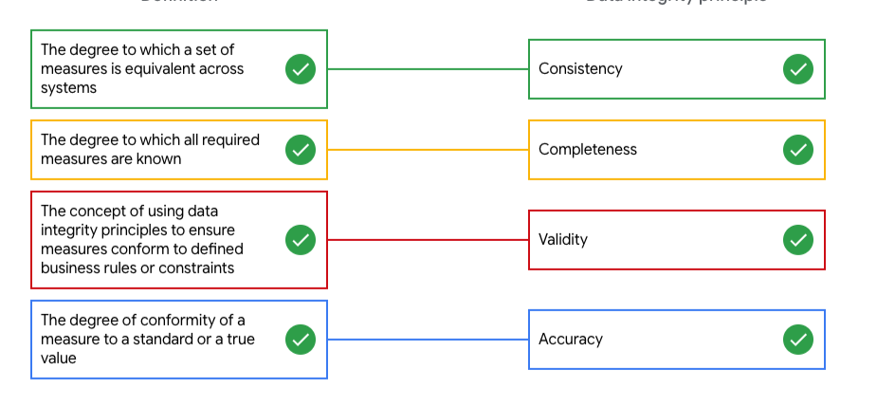
Duplicate data
Description | Possible causes | Potential harm to businesses
Any data record that shows up more than once | Manual data entry, batch data imports, or data migration | Skewed metrics or analyses, inflated or inaccurate counts or predictions, or confusion during data retrieval
Outdated data
Description | Possible causes | Potential harm to businesses
Any data that is old which should be replaced with newer and more accurate information | People changing roles or companies, or software and systems becoming obsolete | Inaccurate insights, decision-making, and analytics
Incomplete data
Description | Possible causes | Potential harm to businesses
Any data that is missing important fields | Improper data collection or incorrect data entry | Decreased productivity, inaccurate insights, or inability to complete essential services
Incorrect/inaccurate data
Description | Possible causes | Potential harm to businesses
Any data that is complete but inaccurate | Human error inserted during data input, fake information, or mock data | Inaccurate insights or decision-making based on bad information resulting in revenue loss
Inconsistent data
Description | Possible causes | Potential harm to businesses
Any data that uses different formats to represent the same thing | Data stored incorrectly or errors inserted during data transfer | Contradictory data points leading to confusion or inability to classify or segment customers
Data engineers:
Transform data into a useful format for analysis, give it a reliable infrastructure; and develop, maintain, and test databases and related systems.

Data warehousing specialists are responsible for ensuring data is available, secure, and backed up to prevent loss.

Data validation is a tool for checking the accuracy and quality of data before adding or importing it. (Make sure it is complete, accurate, secure and consistent)
The data validation process is a form of data cleaning. Data reporting is the process of collecting and submitting data from an analysis.

Using the field length tool to specify the number of characters in each cell in the column would be the most helpful.

A null indicates that a value does not exist. A zero is a numerical response.

Data merging is the process of combining two or more datasets into a single dataset.

Common mistakes to avoid
- Not checking for spelling errors: Misspellings can be as simple as typing or input errors. Most of the time the wrong spelling or common grammatical errors can be detected, but it gets harder with things like names or addresses. For example, if you are working with a spreadsheet table of customer data, you might come across a customer named “John” whose name has been input incorrectly as “Jon” in some places. The spreadsheet’s spellcheck probably won’t flag this, so if you don’t double-check for spelling errors and catch this, your analysis will have mistakes in it.
- Forgetting to document errors: Documenting your errors can be a big time saver, as it helps you avoid those errors in the future by showing you how you resolved them. For example, you might find an error in a formula in your spreadsheet. You discover that some of the dates in one of your columns haven’t been formatted correctly. If you make a note of this fix, you can reference it the next time your formula is broken, and get a head start on troubleshooting. Documenting your errors also helps you keep track of changes in your work, so that you can backtrack if a fix didn’t work.
- Not checking for misfielded values: A misfielded value happens when the values are entered into the wrong field. These values might still be formatted correctly, which makes them harder to catch if you aren’t careful. For example, you might have a dataset with columns for cities and countries. These are the same type of data, so they are easy to mix up. But if you were trying to find all of the instances of Spain in the country column, and Spain had mistakenly been entered into the city column, you would miss key data points. Making sure your data has been entered correctly is key to accurate, complete analysis.
- Overlooking missing values: Missing values in your dataset can create errors and give you inaccurate conclusions. For example, if you were trying to get the total number of sales from the last three months, but a week of transactions were missing, your calculations would be inaccurate. As a best practice, try to keep your data as clean as possible by maintaining completeness and consistency.
- Only looking at a subset of the data: It is important to think about all of the relevant data when you are cleaning. This helps make sure you understand the whole story the data is telling, and that you are paying attention to all possible errors. For example, if you are working with data about bird migration patterns from different sources, but you only clean one source, you might not realize that some of the data is being repeated. This will cause problems in your analysis later on. If you want to avoid common errors like duplicates, each field of your data requires equal attention.
- Losing track of business objectives: When you are cleaning data, you might make new and interesting discoveries about your dataset-- but you don’t want those discoveries to distract you from the task at hand. For example, if you were working with weather data to find the average number of rainy days in your city, you might notice some interesting patterns about snowfall, too. That is really interesting, but it isn’t related to the question you are trying to answer right now. Being curious is great! But try not to let it distract you from the task at hand.
- Not fixing the source of the error: Fixing the error itself is important. But if that error is actually part of a bigger problem, you need to find the source of the issue. Otherwise, you will have to keep fixing that same error over and over again. For example, imagine you have a team spreadsheet that tracks everyone’s progress. The table keeps breaking because different people are entering different values. You can keep fixing all of these problems one by one, or you can set up your table to streamline data entry so everyone is on the same page. Addressing the source of the errors in your data will save you a lot of time in the long run.
- Not analyzing the system prior to data cleaning: If we want to clean our data and avoid future errors, we need to understand the root cause of your dirty data. Imagine you are an auto mechanic. You would find the cause of the problem before you started fixing the car, right? The same goes for data. First, you figure out where the errors come from. Maybe it is from a data entry error, not setting up a spell check, lack of formats, or from duplicates. Then, once you understand where bad data comes from, you can control it and keep your data clean.
- Not backing up your data prior to data cleaning: It is always good to be proactive and create your data backup before you start your data clean-up. If your program crashes, or if your changes cause a problem in your dataset, you can always go back to the saved version and restore it. The simple procedure of backing up your data can save you hours of work-- and most importantly, a headache.
- Not accounting for data cleaning in your deadlines/process: All good things take time, and that includes data cleaning. It is important to keep that in mind when going through your process and looking at your deadlines. When you set aside time for data cleaning, it helps you get a more accurate estimate for ETAs for stakeholders, and can help you know when to request an adjusted ETA.

Data analysts use the clear formats tool to create a clean and consistent visual appearance for their spreadsheets.
Compatibility describes how well two or more datasets are able to work together.

Conditional formatting:
A spreadsheet tool that changes how cells appear when values meet specific conditions

Remove duplicates:
A tool that automatically searches for and eliminates duplicated entries from a spreadsheet

Text string:
A group of characters within a cell, most often composed of letters.

Split:
A tool that divides text around a specified character and puts each fragment into a new, sperate cell.

Concatenate:
A function that joins multiple text strings into a single string.

Delimiter
A delimiter is a character that indicates the beginning or end of a data item.

LEN
A function that tells you the length of a text string by counting the number of characters it contains.

=RIGHT (range, number of characters)

=MID(range, reference starting point, number of middle characters)

The MID function retrieves characters from the middle of the text you supply. LEN is a function data analysts use to determine the length of a text string by counting the number of characters it contains.

= Concatenate (item 1, item 2)

TRIM
A function that removes leading, trailing and repeated spaces in data
Remove duplicates:
A tool that automatically searches for and eliminates duplicate entries from a spreadsheet

One of the most important ways you can streamline your data cleaning is to clean data where it lives. This will benefit your whole team, and it also means you don’t have to repeat the process over and over. For example, you could create a programming script that counted the number of words in each spreadsheet file stored in a specific folder. Using tools that can be used where your data is stored means that you don’t have to repeat your cleaning steps, saving you and your team time and energy.

VLOOPUP
A function that searches for a certain value in a column to return a corresponding piece of information
=VLOOKUP(data to look up, 'where to look'!Range, column, false)

Relational database:
A database that contains a series of tables that can be connected to form relationship

Features of Spreadsheets | Features of SQL Databases
Smaller data sets | Larger datasets
Enter data manually | Access tables across a database
Create graphs and visualizations in the same program | Prepare data for further analysis in another software
Built-in spell check and other useful functions | Fast and powerful functionality
Best when working solo on a project  Generated with a program  Stored locally | Great for collaborative work and tracking queries run by all users  A language  Stored across a database

Distinct:
Select Distinct customer_id
FROM xxxx

In a query, if you use the LENGTH, SUBSTR, or TRIM function in a WHERE clause, you can select data based on a string condition.

LENGTH

Step 1 : SELECT
LENGTH(country) AS letters_in_country
FROM
Customer_data.customer_address

Step 2: SELECT
country
FROM
Customer_data.customer_address
WHERE
LENGTH(country) > 2

SUBSTR

SELECT
DISTINCT Customer_id
FROM
Customer_data.customer_address

WHERE
SUBSTR(country, 1, 2) = ‘US’ % first two letters of each country

SELECT SUBSTRING('SQL Tutorial', 1, 3) AS ExtractString;

TRIM
SELECT
DISTINCT Customer_id
FROM
Customer_data.customer_address
WHERE
TRIM(state) = ‘OH’

DESC

Select xxx
From xxx
ORDER BY
xxxx DESC

FLOAT: a number that contains a decimal
Typecasting: change the type of data from one to another –

CAST function

SELECT
CAST(purchase_price AS FLOAT64)
FROM
customer_data.customer_purchase
ORDER BY
CAST(purchase_price AS FLOAT64) DESC;

SELECT
CAST(date AS date) AS date_only,
purchase_price
FROM
customer_data.customer_purchase
WHERE
date BETWEEN '2020-12-01' AND '2020-12-31'

CONCAT()
- Adds strings together to create new text strings that can be used as unique keys
SELECT
CONCAT(product_code, product_color) AS new_product_code
FROM
customer_data.customer_purchase
WHERE
product = 'couch'

COALESCE()
- Can be used to return non-null values in a list
SELECT
COALESCE(product, product_code) AS product_info
FROM
customer_data.customer_purchase

As a brief review, you learned how to complete tasks like:
- Getting data from a table using SELECT statements
- De-duplicating data using commands like DISTINCT and COUNT + WHERE
- Manipulating string data with TRIM(), SUBSTR, and LENGTH
- Changing data types with CAST

Verification
A process to confirm that a data-cleaning effort was well-executed and the resulting data is accurate and reliable (after data-cleaning)

Changelog
A file containing a chronologically ordered list of modifications made to a project

See the big picture when verifying data-cleaning
- Consider the business problem
- Consider the goal
- Consider the data

Find and replace:
A tool that looks for a specified search term in a spreadsheet and allows you to replace it with something else

Pivot can also do this.

COUNTA
A function that counts the total number of values within a specified range
figure out how many identical errors occur in a dataset

CASE statement
The CASE statement goes through one or more conditions and returns a value as soon as a condition is met
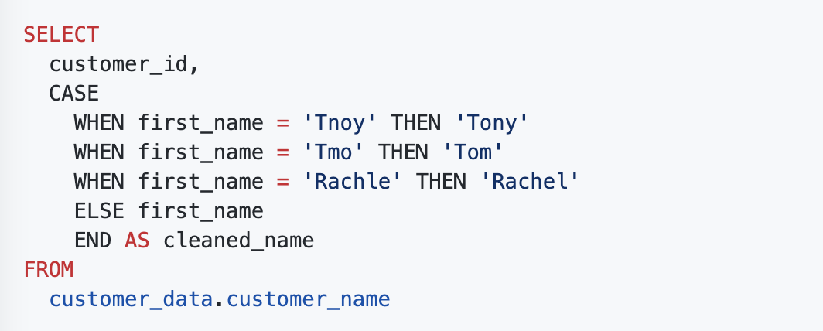

Correct the most common problems
Make sure you identified the most common problems and corrected them, including:
- Sources of errors: Did you use the right tools and functions to find the source of the errors in your dataset?
- Null data: Did you search for NULLs using conditional formatting and filters?
- Misspelled words: Did you locate all misspellings?
- Mistyped numbers: Did you double-check that your numeric data has been entered correctly?
- Extra spaces and characters: Did you remove any extra spaces or characters using the TRIM function?
- Duplicates: Did you remove duplicates in spreadsheets using the Remove Duplicates function or DISTINCT in SQL?
- Mismatched data types: Did you check that numeric, date, and string data are typecast correctly?
- Messy (inconsistent) strings: Did you make sure that all of your strings are consistent and meaningful?
- Messy (inconsistent) date formats: Did you format the dates consistently throughout your dataset?
- Misleading variable labels (columns): Did you name your columns meaningfully?
- Truncated data: Did you check for truncated or missing data that needs correction?
- Business Logic: Did you check that the data makes sense given your knowledge of the business
Documentation:
The process of tracking changes, additions, deletions, and errors involved in your data-cleaning effort

Having a record of how a data set evolved does three very important things.
- Recover data-cleaning errors – assuming the data errors are not fixable
- Inform other users of changes - assuming not fixable
- Determine quality of data
The instructor stated that the first two benefits of documentation --1) recalling the errors that were cleaned and 2) informing others of the changes -- assume that the data errors aren't fixable. She then added that when the data errors are fixable, the documentation needs to record how the data was fixed. Data-cleaning documentation is important in both cases.

A changelog can build on your automated version history by giving you an even more detailed record of your work.
Typically, a changelog records this type of information:
- Data, file, formula, query, or any other component that changed
- Description of what changed
- Date of the change
- Person who made the change
- Person who approved the change
- Version number
- Reason for the change
- A company has official versions of important queries in their version control system.
- An analyst makes sure the most up-to-date version of the query is the one they will change. This is called syncing
- The analyst makes a change to the query.
- The analyst might ask someone to review this change. This is called a code review and can be informally or formally done. An informal review could be as simple as asking a senior analyst to take a look at the change.
- After a reviewer approves the change, the analyst submits the updated version of the query to a repository in the company's version control system. This is called a code commit. A best practice is to document exactly what the change was and why it was made in a comments area. Going back to our example of a query that pulls daily revenue, a comment might be: Updated revenue to include revenue coming from the new product, Calypso.
- After the change is submitted, everyone else in the company will be able to access and use this new query when they sync to the most up-to-date queries stored in the version control system.
- If the query has a problem or business needs change, the analyst can undo the change to the query using the version control system. The analyst can look at a chronological list of all changes made to the query and who made each change. Then, after finding their own change, the analyst can revert to the previous version.
- The query is back to what it was before the analyst made the change. And everyone at the company sees this reverted, original query, too.
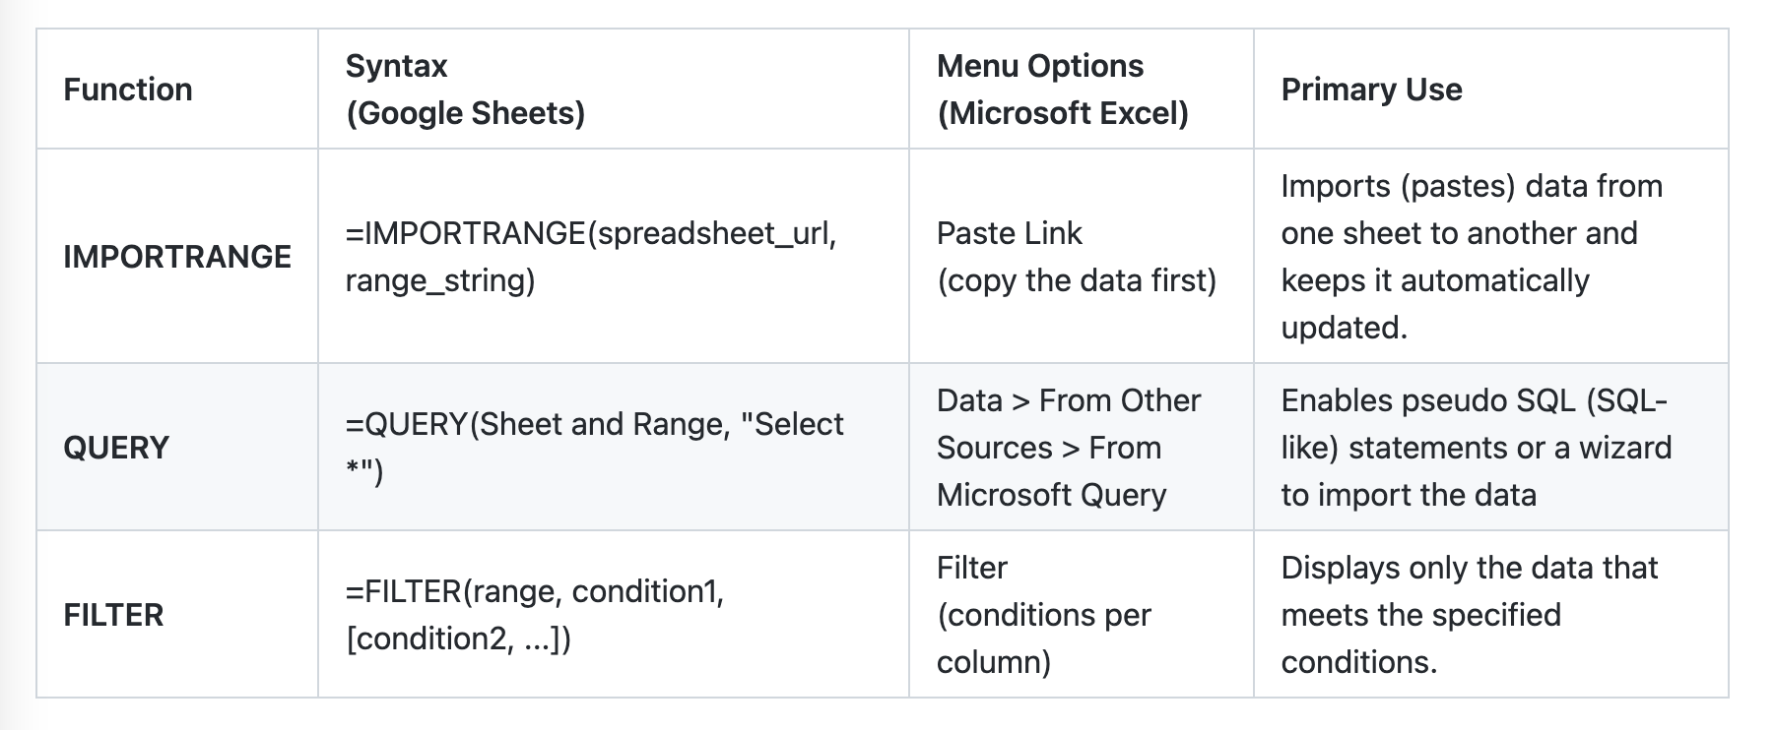

The IMPORTRANGE function in Google Sheets and the Paste Link feature (a Paste Special option in Microsoft Excel) both allow you to insert data from one sheet to another.
The QUERY function is also useful when you want to pull data from another spreadsheet.
The FILTER function is fully internal to a spreadsheet and doesn’t require the use of a query language. The FILTER function might run faster than the QUERY function. But keep in mind, the QUERY function can be combined with other functions for more complex calculations.

Course 5: Analyze Data to Answer Questions

Analysis:
The process used to make sense of the data collected

The goal of analysis is to identify trends and relationships within the data so that you can accurately answer the question you're asking.

4 phases of analysis:
- Organize data
- Format and adjust data
- Get input from others
- Transform data

An analyst sorts and filters data during the format and adjust analysis phase.

Getting input means soliciting information from other sources to inform your decisions. Formatting and adjusting data involves rearranging the data in the spreadsheet to make it easier to work with.

transforming data, which involves identifying relationships and patterns between the datasets and making calculations based on the data. Formatting and adjusting data involves rearranging the data to make it easier to work with.

Sorting a list of students alphabetically is an example of formatting and adjusting data.

The organization of datasets is really important for data analysts. Most of the datasets you will use will be organized as tables. Tables are helpful because they let you manipulate your data and categorize it. Having distinct categories and classifications lets you focus on, and differentiate between, your data quickly and easily.
Data analysts also need to format and adjust data when performing an analysis. Sorting and filtering are two ways you can keep things organized when you format and adjust data to work with it. For example, a filter can help you find errors or outliers so you can fix or flag them before your analysis. Outliers are data points that are very different from similarly collected data and might not be reliable values. The benefit of filtering the data is that after you fix errors or identify outliers, you can remove the filter and return the data to its original organization.

Sorting is when you arrange data into a meaningful order to make it easier to understand, analyze, and visualize. It ranks your data based on a specific metric you choose. You can sort data in spreadsheets, SQL databases (when your dataset is too large for spreadsheets), and tables in documents.
Filtering is used when you are only interested in seeing data that meets a specific criteria, and hiding the rest. Filtering is really useful when you have lots of data. You can save time by zeroing in on the data that is really important or the data that has bugs or errors. Most spreadsheets and SQL databases allow you to filter your data in a variety of ways. Filtering gives you the ability to find what you are looking for without too much effort.

Sorting in a pivot table
Items in the row and column areas of a pivot table are sorted in ascending order by any custom list first. For example, if your list contains days of the week, the pivot table allows weekday and month names to sort like this: Monday, Tuesday, Wednesday, etc. rather than alphabetically like this: Friday, Monday, Saturday, etc.
If the items aren’t in a custom list, they will be sorted in ascending order by default. But, if you sort in descending order, you are setting up a rule that controls how the field is sorted even after new data fields are added.

If "Sort sheet" is applied, all of the data in a spreadsheet is sorted by the conditions of a single column, but the related information across each row stays together.
On the other hand, "Sort range" doesn't keep the information across rows together.
When you sort a range, you're selecting a specific collection ofcells or the range that you want the sorting limited to.

Customized sort order
When you sort data in a spreadsheet using multiple conditions.

The sort from a spreadsheet's Data tab can exclude a header row in the data range from being sorted, while the data range for a written SORT function should never contain a header row.
The sort from a spreadsheet's Data tab overwrites the cells containing the unsorted data with the sorted data, while a written SORT function inserts the sorted data in a different cell range.

Sorting ranks data based on a specific metric that you select.

Incorrectly formatted data can:
Lead to mistakes Take time to fix Affect stakeholder’s decision making
Data Validation:
- data validation is used to add drop-down lists to cells with predetermined options for users to choose from
- creating customer checkboxes
- protect structured data and formulas

CAST function – transforming data in SQL
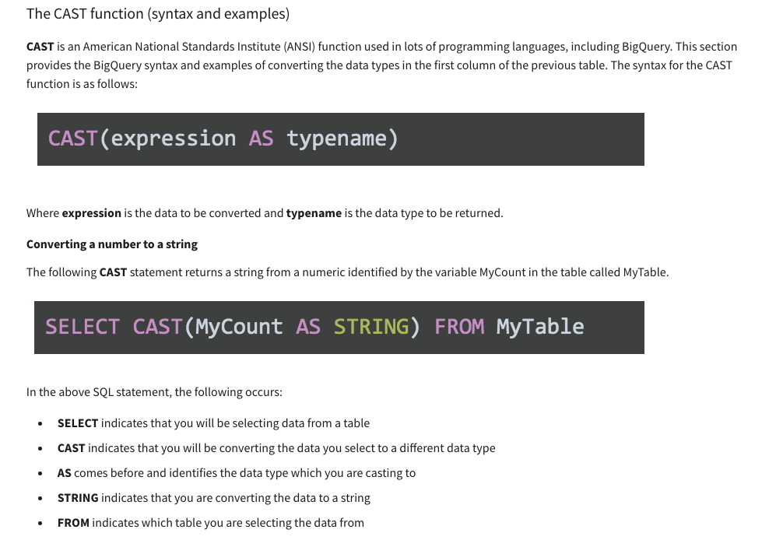

To ensure spreadsheet tools continue to run correctly, even if someone enters the wrong data by mistake, select Reject Invalid Inputs.

LEN
LEFT
RIGHT
FIND

CONCAT at work
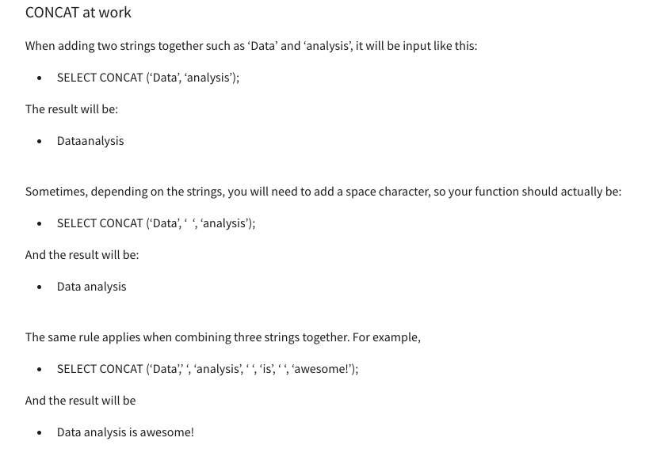

Data aggregation
The process of gathering data from multiple sources in order to combine it into a single summarized collection
Subquery: a query within another query

VALUE:
A function that converts a text string that represents a number to a numerical value

VLOOKUP(103,A3:B26,2,FALSE)
103: represents the exact value we search for; A3:B26 is the range, 2 is the second column, FALSE to find the exact match (true means find the close match)

VLOOKUP only returns the first match it finds

MATCH:
A function used to locate the position of a specific lookup value

TRUE tells VLOOKUP to look for approximate matches
FALSE tells VLOOKUP to look for exact matches
VLOOKUP (A2,’Sheet 2’ !A:B,TRUE): for ture, it will stop when it finds a value = or > A2

Two common reasons to use VLOOKUP are:
- Populating data in a spreadsheet
- Merging data from one spreadsheet with data in another

You can use the IFNA function to replace the #N/A error with something more descriptive, like “Does not exist.”

JOIN
A SQL clause that is used to combine rows from two or more tables based on a related column
Common JOINs:
Inner, left, right, outer

INNER JOIN: a function that returns records with matching values in both tables
LEFT JOIN: a function returns all the records from the left table and only the matching records from the right table
RIGHT JOIN: xxx
OUTER JOIN:
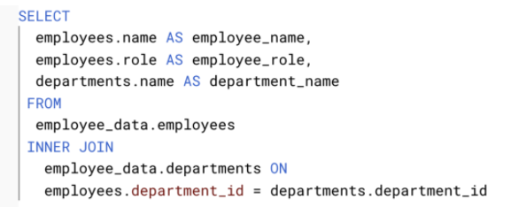
Aliasing is the process of using aliases.

Notice that AS is preceded by the table name and followed by the new nickname. It is a similar approach to aliasing a column:
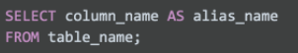
To temporarily name a column in a query to make it easier to read and write, the analyst should use aliasing.

How Many questions:
COUNT in spreadsheet:
Can be used to count the total number of numerical values within a specific range in spreadsheets
COUNT in SQL
A query that returns the number of rows in a specified range
COUNT (DISTINCT xxx)
A query that only returns the distinct values in a specific range (does no duplicated values)

WHERE xxx GROUP BY
GROUP BY xxx WHERE two different functions
HAVING
Allows you to add a filter to your query instead of the underlying table that can only be used with aggregate functions
CASE
Returns records with your conditions by allowing you to include if/then statements in your query

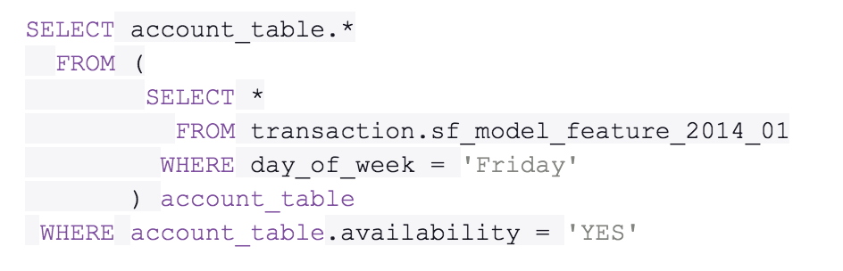
There are a few rules that subqueries must follow:
- Subqueries must be enclosed within parentheses
- A subquery can have only one column specified in the SELECT clause. But if you want a subquery to compare multiple columns, those columns must be selected in the main query.
- Subqueries that return more than one row can only be used with multiple value operators, such as the IN operator which allows you to specify multiple values in a WHERE clause.
- A subquery can’t be nested in a SET command. The SET command is used with UPDATE to specify which columns (and values) are to be updated in a table.
- Comparison operators such as >, <, or = help you compare data in subqueries. You can also use multiple row operators including IN, ANY, or ALL.
- A subquery is called an inner query or inner select because it’s nested in a statement called an outer query or outer select.
- The innermost query executes first. Its parent query executes last so it can use the results returned by inner queries.

=COUNIF (range, ‘‘value’’)
=COUNTIF(range, ‘”=1”’), =COUNTIF(range,”>1”)
=COUNTIFS(criteria_range1, criterion1, [criteria_range2, criterion2, ...])

=SUMIF(range1, criteria/condition,[sum_range2])
=SUMIF(range1,’’=1’’,another range)

=SUMIFS(sum_range, criteria_range1, criterion1, [criteria_range2, criterion2, ...])

SUMPRODUCT
A function that multiplies arrays and returns the sum of those products
=sumproduct (array1, [array2]…)
Array: a collection of values in cells
The Summarize By drop-down menu changes the function applied to the values. The SUM function is the default function, but there are other options, such as COUNT. Other tools, such as the Data menu, can be used for sorting.

Pivot tables make it possible to view data in multiple ways in order to identify insights and trends. They can help you quickly make sense of larger data sets by comparing metrics, performing calculations, and generating reports.
A pivot table has four basic parts: rows, columns, values, and filters.
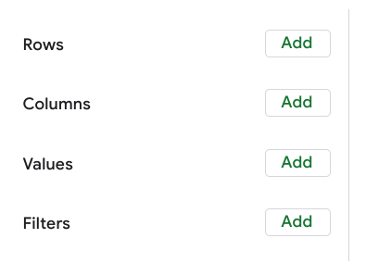
The rows of a pivot table organize and group data you select horizontally.
The columns organize and display values from your data vertically. Similar to rows, columns can be pulled directly from the data set or created using values. Values are used to calculate and count data. This is where you input the variables you want to measure. This is also how you create calculated fields in your pivot table. As a refresher, a calculated field is a new field within a pivot table that carries out certain calculations based on the values of other fields
the filters section of a pivot table enables you to apply filters based on specific criteria — just like filters in regular spreadsheets

SELECT
Column A
Column B
Column C
(Column A + Column B) *Column C AS Column X

Spreadsheet: AVERAGE
SQL: AVG
Not equal to <>
Using underscores instead of spaces helps avoid potential issues with servers and applications. It also helps to keep the column names readable.

GROUP BY
A command that groups rows that have the same values from a table into summary rows.

EXTRACT
The purpose of the EXTRACT command in a query is to extract a part from a given date. The EXTRACT command can extract any part from a date/time value. The SELECT command can extract a column from a database.

The modulo operator returns the remainder of a division calculation when included in a SQL query.

Types of Data Validation
The first five are validation types associated with the data (type, range, constraint, consistency, and structure) and the sixth type focuses on the validation of application code used to accept data from user input.

Data type
- Purpose: Check that the data matches the data type defined for a field.
- Example: Data values for school grades 1-12 must be a numeric data type.
- Limitations: The data value 13 would pass the data type validation but would be an unacceptable value. For this case, data range validation is also needed.

Data range
- Purpose: Check that the data falls within an acceptable range of values defined for the field.
- Example: Data values for school grades should be values between 1 and 12.
- Limitations: The data value 11.5 would be in the data range and would also pass as a numeric data type. But, it would be unacceptable because there aren't half grades. For this case, data constraint validation is also needed.

Data constraints
- Purpose: Check that the data meets certain conditions or criteria for a field. This includes the type of data entered as well as other attributes of the field, such as number of characters.
- Example: Content constraint: Data values for school grades 1-12 must be whole numbers.
- Limitations: The data value 13 is a whole number and would pass the content constraint validation. But, it would be unacceptable since 13 isn’t a recognized school grade. For this case, data range validation is also needed.

Data consistency
- Purpose: Check that the data makes sense in the context of other related data.
- Example: Data values for product shipping dates can’t be earlier than product production dates.
- Limitations: Data might be consistent but still incorrect or inaccurate. A shipping date could be later than a production date and still be wrong.

Code Validation
- Purpose: Check that the application code systematically performs any of the previously mentioned validations during user data input.
- Example: Common problems discovered during code validation include: more than one data type allowed, data range checking not done, or ending of text strings not well defined.
- Limitations: Code validation might not validate all possible variations with data input.

The data-validation process takes place throughout your analysis.

A temporary table is created and exists for a short time on a database server.
A data analyst has a large number of sales records in a table. They want to perform calculations on a small subset of the table. Rather than filtering the data over and over

WITH xxx AS (
SELECT *
FROM data_set_name
WHERE xxx> 66
)
## explanation, not the code

SELECT
COUNT(*) AS cnt
FROM
Xxx

WITH clauses, CREATE TABLE statements, and CREATE TEMP TABLE statements all create temporary tables in queries.

Temporary tables are automatically deleted after ending the session in a SQL database.

A CREATE TABLE statement provides access for anyone to use the temporary table.

Four elements of good data visualization:
- Information: the data you are working with
- Story: a clear and compelling narrative or concept
- Goal: a specific objective or function for the visual
- Visual form: an effective use of metaphor or visual expression

Bar Graphs: use size contrast to compare two or more values
Pie Charts: show how much each part of something makes up the whole
Maps: help organize data geographically
Histogram: a chart that shows how often data values fall into certain ranges.
One of your biggest considerations when creating a data visualization is where
you'd like your audience to focus.

Causation, or a cause-effect relationship, occurs when an action directly leads to an outcome. Two events that relate to one another, but one doesn’t necessarily cause the other, describes correlation.

In your data analysis, remember to:
- Critically analyze any correlations that you find
- Examine the data’s context to determine if a causation makes sense (and can be supported by all of the data)
- Understand the limitations of the tools that you use for analysis

Course 6: Share Data Through the Art of Visualization

Tableau
A business intelligence and analytics platform that helps people see, understand, and make decisions with data

- Change: This is a trend or instance of observations that become different over time. A great way to measure change in data is through a line or column chart.
- Clustering: A collection of data points with similar or different values. This is best represented through a distribution graph.
- Relativity: These are observations considered in relation or in proportion to something else. You have probably seen examples of relativity data in a pie chart.
- Ranking: This is a position in a scale of achievement or status. Data that requires ranking is best represented by a column chart.
- Correlation: This shows a mutual relationship or connection between two or more things. A scatter plot is an excellent way to represent this type of data pattern.

The elements of art:
Line, Shape, Color, Space, Movement
Lines add visual form to your data and help build the structure for your visualization.

Nine basic principles of design
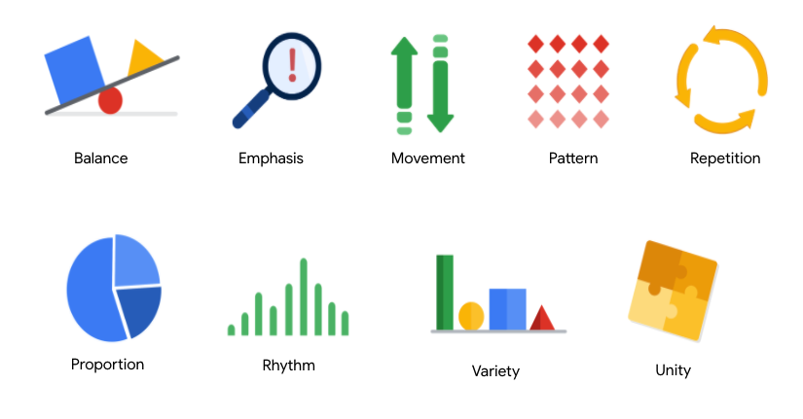
1. Balance: The design of a data visualization is balanced when the key visual elements, like color and shape, are distributed evenly. This doesn’t mean that you need complete symmetry, but your visualization shouldn’t have one side distracting from the other. If your data visualization is balanced, this could mean that the lines used to create the graphics are similar in length on both sides, or that the space between objects is equal. For example, this column chart (also shown below) is balanced; even though the columns are different heights and the chart isn’t symmetrical, the colors, width, and spacing of the columns keep this data visualization balanced. The colors provide sufficient contrast to each other so that you can p
ay attention to both the motivation level and the energy level displayed.

2. Emphasis: Your data visualization should have a focal point, so that your audience knows where to concentrate. In other words, your visualizations should emphasize the most important data so that users recognize it first. Using color and value is one effective way to make this happen. By using contrasting colors, you can make certain that graphic elements—and the data shown in those elements—stand out.

3. Movement: Movement can refer to the path the viewer’s eye travels as they look at a data visualization, or literal movement created by animations. Movement in data visualization should mimic the way people usually read. You can use lines and colors to pull the viewer’s attention across the page.

4. Pattern: You can use similar shapes and colors to create patterns in your data visualization. This can be useful in a lot of different ways. For example, you can use patterns to highlight similarities between different data sets, or break up a pattern with a unique shape, color, or line to create more emphasis.

5. Repetition: Repeating chart types, shapes, or colors adds to the effectiveness of your visualization. Think about the book sales chart from the previous example: the repetition of the colors helps the audience understand that there are distinct sets of data. You may notice this repetition in all of the examples we have reviewed so far. Take some time to review each of the previous examples and notice the elements that are repeated to create a meaningful visual story.
6. Proportion: Proportion is another way that you can demonstrate the importance of certain data. Using various colors and sizes helps demonstrate that you are calling attention to a specific visual over others. If you make one chart in a dashboard larger than the others, then you are calling attention to it. It is important to make sure that each chart accurately reflects and visualizes the relationship among the values in it. In this dashboard (also shown below), the slice sizes and colors of the pie chart compared to the data in the table help make the number of donuts eaten by each person the focal point.
7. Rhythm: This refers to creating a sense of movement or flow in your visualization. Rhythm is closely tied to the movement principle. If your finished design doesn’t successfully create a flow, you might want to rearrange some of the elements to improve the rhythm.
8. Variety: Your visualizations should have some variety in the chart types, lines, shapes, colors, and values you use. Variety keeps the audience engaged. But it is good to find balance since too much variety can confuse people. The variety you include should make your dashboards and other visualizations feel interesting and unified.
9. Unity: The last principle is unity. This means that your final data visualization should be cohesive. If the visual is disjointed or not well organized, it will be confusing and overwhelming.
Being a data analyst means learning to think in a lot of different ways. These nine principles of design can help guide you as you create effective and interesting visualizations.

Data visualizations have three essential elements: clear meaning, a sophisticated use of contrast, and refined execution.
Refined execution means paying deep attention to detail. This is done by using visual elements such as lines, shapes, colors, value, space, and movement.

The Venn diagram by David McCandless identifies four elements of successful visualizations:
- Information (data): The information or data that you are trying to convey is a key building block for your data visualization. Without information or data, you cannot communicate your findings successfully.
- Story (concept): Story allows you to share your data in meaningful and interesting ways. Without a story, your visualization is informative, but not really inspiring.
- Goal (function): The goal of your data visualization makes the data useful and usable. This is what you are trying to achieve with your visualization. Without a goal, your visualization might still be informative, but can’t generate actionable insights.
- Visual form (metaphor): The visual form element is what gives your data visualization structure and makes it beautiful. Without visual form, your data is not visualized yet.

Design thinking for data visualization involves five phases:
- Empathize: Thinking about the emotions and needs of the target audience for the data visualization
- Define: Figuring out exactly what your audience needs from the data
- Ideate: Generating ideas for data visualization
- Prototype: Putting visualizations together for testing and feedback
- Test: Showing prototype visualizations to people before stakeholders see them
Design thinking is a process used to solve complex problems in a user-centric way. It enables data analysts to identify alternative strategies for visualizations.

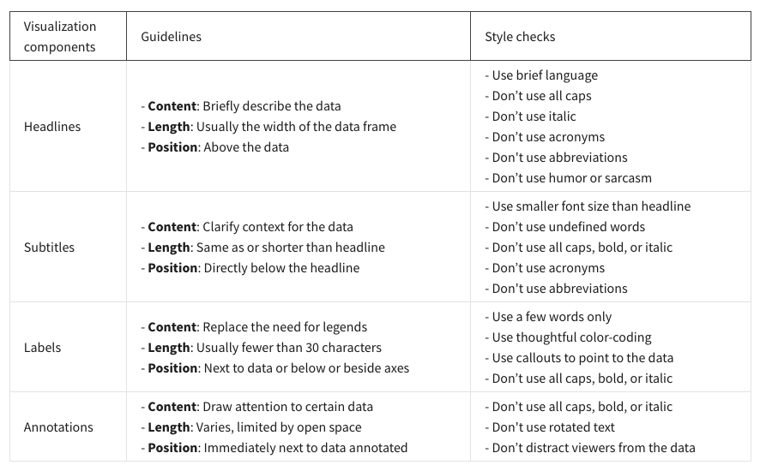
Designing with an accessibility mindset involves thinking about your audience ahead of time; focusing on simple, easy to understand visuals; and creating alternative ways for your audience to access and interact with your data.

Diverging color palette
Displays two ranges of values using color intensity to show the magnitude of the number and the actual color to show which range the number is from.
Data storytelling is communicating the meaning of a data set with visuals and a narrative that are customized for each particular audience.

3 data storytelling steps:
  - Engage your audience
  - Create compelling visuals
  - Tell the story in an interesting narrative
A data analyst uses spotlighting to pinpoint the most relevant data derived from their analysis and eliminate the less important details. Spotlighting involves scanning the data to quickly identify the most important insights.

In Tableau, floating items can be layered over other objects. Tiled items are part of a single-layer grid that automatically resizes based on the overall dashboard size.

Filters in Tableau can be used to limit information, customize information, or highlight a data point.

S​tatic data involves providing screenshots or snapshots in presentations or building dashboards using snapshots of data. There are pros and cons to static data.
PROS
- Can tightly control a point-in-time narrative of the data and insight
- Allows for complex analysis to be explained in-depth to a larger audience
CONS
- Insight immediately begins to lose value and continues to do so the longer the data remains in a static state
- S​napshots can't keep up with the pace of data change

L​ive data means that you can build dashboards, reports, and views connected to automatically updated data.
PROS
- Dashboards can be built to be more dynamic and scalable
- Gives the most up-to-date data to the people who need it at the time when they need it
- Allows for up-to-date curated views into data with the ability to build a scalable “single source of truth” for various use cases
- Allows for immediate action to be taken on data that changes frequently
- Alleviates time/resources spent on processes for every analysis
CONS
- Can take engineering resources to keep pipelines live and scalable, which may be outside the scope of some companies' data resource allocation
- Without the ability to interpret data, you can lose control of the narrative, which can cause data chaos (i.e. teams coming to conflicting conclusions based on the same data)
- Can potentially cause a lack of trust if the data isn’t handled properly

The aha moment means sharing data-driven recommendations for success.

Characters are people affected by your story.

The plot is what creates the conflict that compels the characters to act—and what the data analysis seeks to resolve.

The Big reveal is how data solves the problem.

Setting is what’s happening and other background info

Pre-filtering is useful because it saves time and effort while directing stakeholders to the most important data.

The framework for your presentation starts with your understanding of the business task.

The purpose of a framework is to create logical connections that tie back to the business task. It also gives your audience context about your data and helps you focus on the most important information.

The McCandless Method
  - Introduce the graphic by name
  - Answer obvious questions before they’re asked
  - State the insight of your graphic
  - Call out data to support that insight
  - Tell your audience why it is important (so what)

Good data presentation
In the second video, numerous best practices are applied to create a better presentation on the same topic. This “good” presentation is so much easier to understand than the messy one! Here is a preview:
- Title and date the presentation was last updated
- Flow or table of contents
- Transition slides
- Visual introduction to the data (also used as a repeated theme)
- Animated bullet points
- Annotations on top of visuals
- Logic and progression
- Limitations to the data (caveats) - what the data can’t tell you

TWO KEY responsibly:
- Analyze data
- Present your analyses
Be prepared to consider any limitations of your data by:
- Critically analyzing the correlations
- Looking at the context

Before the presentation
- Assemble and prepare your questions.
- Discuss your presentation with your manager, other analysts, or other friendly contacts in your organization.
- Ask a manager or other analysts what sort of questions were normally asked by your specific audience in the past.
- Seek comments, feedback, and questions on the deck or the document of your analysis.
- At least 24 hours ahead of the presentation, try and brainstorm tricky questions or unclear parts you may come across- this helps avoid surprises.
- It never hurts to practice what you will be presenting, to account for any missing information or simply to calm your nerves.

During the presentation
- Be prepared to respond to the things that you find and effectively and accurately explain your findings.
- Address potential questions that may come up.
- Avoid having a single question derail a presentation and propose following-up offline.
- Put supplementary visualizations and content in the appendix to help answer questions.

Handling of objections

Course 7: Data Analysis wit R programming

Programming languages are the words and symbols we use to write instructions for computers to follow.
Coding is writing instructions to the computer in the syntax of a specific programming language.

Advantages of programming:
- Clarify the steps of your analysis
- Saves times
- Reproduce and share your work

R offers convenient statistical features for data analysis and is useful for creating advanced data visualizations
Python is a general-purpose language that you can use to create what you need for data analysis.

Spreadsheets, SQL, and R: a comparison
There are two main things that all three have in common:
- They all use filters: for example, you can easily filter a dataset using any of these tools. In R, you can use the filter function. This performs the same task as a basic SELECT-FROM-WHERE SQL query. In a spreadsheet, you can create a filter using the menu options.
- They all use functions: In spreadsheets, you use functions in formulas, and in SQL, you include them in queries. In R, you will use functions in the code that is part of your analysis.

R is accessible, data-centric, open-source and has an active community of users.
First R is an accessible language for beginners. Lots of people without a traditional
programming language learn R.
R is what's known as a data-centric programming language. It's specifically designed to make data analysis easier, more efficient and more powerful.
Another awesome thing about R is that it's open source. Open source means that the code is freely available and may be modified and shared by the people who use it.
For now, just know that literally housands of R packages exist, and they were all built by people who
wanted to solve specific problems. A lot of these packages are super useful for data analysts.

- Reproducing your analysis
- Processing lots of data
- Creating data visualization

RStudio's an IDE or integrated development environment.
This means that RStudio brings together all the tools you might want to use in a single place.
IDE: integrated development environment

Function （R）
A body of reusable code used to perform specific task in R

Argument (R)
Information that a function in R needs in order to run

Variable (R )
A representation of a value in R that can be stored for use later during programming
A variable name should start with a letter and can also contain numbers and underscores.

Hash key #
Asterisk *

Vector (R )
A group of data elements in the same type stored in a sequence in R

Pipe (R )
A tool in R expressing a sequence of multiple operations, represented with “%>%”

Foundation for using R:

Functions
Comments
Variables
Data types
Vector
Pipe

In programming, a data structure is a format for organizing and storing data
The most common data structures in the R programming language include:
- Vectors
- Data frames
- Matrices
- Arrays
There are two types of vectors: atomic vectors and lists.

Every vector you create will have two key properties: type and length.

Lists are different from atomic vectors because their elements can be of any type—like dates, data frames, vectors, matrices, and more. Lists can even contain other lists.

Assignment operators
Used to assign values to variables and vectors

Arithmetic operators
Used to completed math calculations

AND operator “&”

OR operator “|”

NOT operator “!” exclamation point

Package (R )

Units of reproducible R code.

Packages in R includes:

Reusable R functions, Documentation about the functions, sample dataset, test for checking your code

CRAN (comprehensive R archive Network)

An online archive with R packages, source code, manuals, and documentation

Tidyverse(R )

A system of packages in R with a common design philosophy for data manipulation, exploration, and visualization
With ggplot2, you can create a variety of data viz by applying different visual properties to the data variables.

Tidyr is a package used for data cleaning to make tidy data.
Tidyr works with wide and long data to make sure this happens.
readr, which is used for importing data. read_csv A CSV file contains data separated by commas in a table format.
To accurately read a dataset with readr, you combine the function with a column specification.

Dplyr offers a consistent set of functions that help you complete some common data manipulation tasks.

Tibble works with data frames.
Purrr works with functions and vectors helping make your code easier to write and more expressive.
Stringr includes functions that make it easier to work with strings.
Forcats provides tools that solve common problems with factors.

Pipe %>%
Nested: Nested describes code that performs a particular function and is contained within code that performs a broader function.

a nested function, which is a function that is completely contained within another function. INSIDE OUT

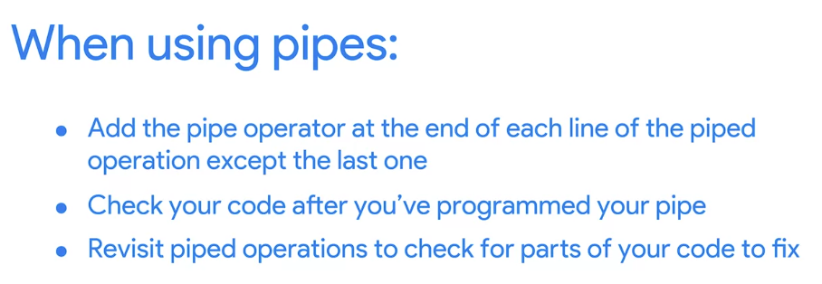

Data frame
A collection of columns

Standards of tidy data: Variables are organized into columns, observations are organized into rows, and each value must have its own cell. Naming columns is a best practice for creating data frames.
(Tidy data is a standard way of mapping the meaning of a dataset to its structure.)
Tidy data refers to the principles that make data structures meaningful and easy to understand. It’s a way of standardizing the organization of data within R.
When creating data frames:
- Columns should be named.
- Data stored can by many different types, numeric, factor
- Each column should contain the same number of values

Tibbles
- Never change the data types of the inputs
- Never change the names of your variables
- Never create row names
- Make printing in R easier

tibble() is a nice way to create data frames.
Tibbles are a little different from standard data frames. A data frame is a collection of columns, like a spreadsheet or a SQL table. Tibbles are like streamlined data frames that are automatically set to pull up only the first 10 rows of a dataset, and only as many columns as can fit on the screen.
You can create a tibble from existing data with the as_tibble() function

Str() – checking structure, converts values to a string form
Head() – to get the first parts of a vector, matrix, table, data frame or function
Mutate() – create a new variable from a data set
glimpse() is like a transposed version of print() : columns run down the page, and data runs across. This makes it possible to see every column in a data frame. It's a little like str() applied to a data frame but it tries to show you as much data as possible.

earnings_df <- read_csv("quarter_earnings.csv")

summary functions:
skim_without_charts()
glimpse()
head()
select()

rename() changes the name of columns rename(new_name = previous_name)

rename(datasetName, tolower/toupper)

File Name

Do
- Keep your filenames to a reasonable length
- Use underscores and hyphens for readability
- Start or end your filename with a letter or number
- Use a standard date format when applicable; example: YYYY-MM-DD
- Use filenames for related files that work well with default ordering; example: in chronological order, or logical order using numbers first

Don't
- Use unnecessary additional characters in filenames
- Use spaces or “illegal” characters; examples: &, %, #, <, or >
- Start or end your filename with a symbol
- Use incomplete or inconsistent date formats; example: M-D-YY
- Use filenames for related files that do not work well with default ordering; examples: a random system of numbers or date formats, or using letters first

In R, == means exactly equal to

pivot_longer pivot_wider

The bias() function can be used to calculate the average amount a predicted outcome and actual outcome differ in order to determine if the data model is biased.

Benefits of ggplot2:
- Create different types of plots
- Customize the look and feel of plots
- Create high quality visuals
- Combine data manipulation and visualization

Aesthetic(R )
A visual property of an object in your plot

Geom (R )
The geometric object used to represent your data

Facets (R )
Let you display smaller groups, or subsets of your data

Label and annotate function
Let you customize your data

Mapping (R )
Matching up a specific variable in your dataset with a specific aesthetic

- Start with the ggplot function and choose a dataset to work with
- Add a geom_funtion to display your data
- Map the variables you want to plot tin the arguments of the aes() function

In ggplot2, you can use the ggplot() function to specify the data frame to use for your plot.

In ggplot2, you use the aes() function to map variables in your data to visual features of your plot. These features are known as aesthetics.

The function geom_point() uses points to create a scatterplot.
ggplot(data = penguins) +
geom_point(mapping = aes(x = flipper_length_mm, y = body_mass_g))

In this reading, you will learn about the three basic aesthetic attributes to consider when creating ggplot2 visualizations in R: color, size, and shape.

smoothing

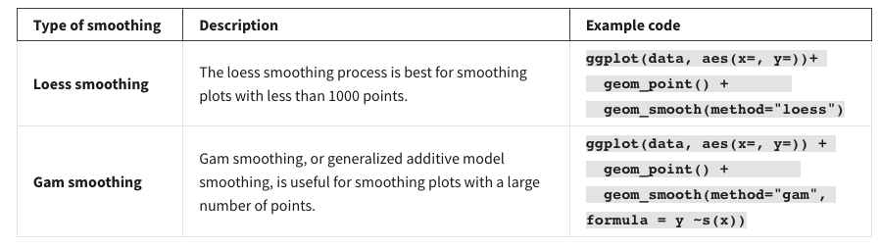

Facet_warp()
facet_wrap() wraps a 1d sequence of panels into 2d.

Facet_grid()
facet_grid() forms a matrix of panels defined by row and column faceting variables.
Facet_grid(A~B)

Difference: facet_wrap() : "wraps" a 1d ribbon of panels into 2d. facet_grid() : produces a 2d grid of panels defined by variables which form the rows and columns.

Blue and yellow bars
To highlight underperforming products, use an aesthetics function: col = ifelse (x<2, 'blue', 'yellow').

Bar chart
To create the bars on the chart, use a geom function: geom_bar ().

Chart title
To add a title to the chart, use a label function: title = Average product rating.

Annotate
To add notes to a document or diagram to explain or comment upon it
Annotation(‘’text’’,x=220,y=200,label=’’xxx’’,color=red,fontface=’’ ‘’,size= , angle=25)

Title, subtitle,caption
Labs(title = ‘’xxxx’’,subtitle=’’xxx’’,caption=’’xxx’’)

Export save function
ggsave() quotation mark ‘’ ‘’ open quotation mark closing quotation mark

To save images without using ggsave(), you can open an R graphics device like png() or pdf(); these will allow you to save your plot as a .png or .pdf file. You can also choose to print the plot and then close the device using dev.off().

R Markdown is a file format for making dynamic documents with R.
R Markdown is a useful tool that allows you to save and execute code, and generate shareable reports for stakeholders.

Markdown
A syntax for formatting plain text files

Markdown formatting
Add a_signle_underscore or asterisk *

Interactive R markdown option: R notebook
Lets users run your code and show the graphs and charts that visualize the code
R markdown in a great tool for documenting your analysis at any stage
R Markdown files can be converted into HTML, PDF and Word, slideshow presentations, or dashboards.
The knit button will produce a report containing all text, code, and results from the R Markdown file.

Inline code can be inserted directly into the text of an .rmd file.

Hashtags are used for headers; for example, ### Results indicates that Results is a Header 3 style heading because there three hashtags.
To make a header smaller, add more hashtags before the title. For example, ### Conclusion would be smaller than ## Conclusion.

The knit button creates a shareable HTML report of the R Markdown file.
The code chunks are run and the output appears in the HTML report.

HTML
The set of markup symbols or codes used to create a webpage

[link](http://)
![plot this way] (http://)

Code Chunk
Code added in an .Rmd file

Delimiter
A character that indicates the beginning or end of a data item
Code chunk delimitters: ‘’’{r}and’’’
If you format a code chunk with two ticks inside of three, it would appear as regular non-code text. Delimiters are characters that designate code, so it is important that they be in the correct syntax. Going forward, you can pay attention to delimiters to guarantee your R Markdown notebook will run your code properly.

Course 8:

Portfolio
Collection of case studies that can be shared with potential employers

Ins and outs of building your portfolio
First and foremost, your portfolio should represent your own work. While getting ideas from other portfolios is inspiring, directly copying (or only slightly modifying) others’ work and sharing it in your own portfolio is never acceptable.
Additionally, if you work on a project as a data analyst, keep in mind that the work you do for an employer or client belongs to their business. In many cases, you can’t share that work publicly in your personal portfolio without direct and explicit permission from them beforehand.
Finally, be cautious even with open or public datasets. Unless you are using data that you personally collected, ask the owner of the data for permission before you post anything related to the data in your portfolio. You should always take full responsibility for what you publish by getting the right permissions as needed.

Template of the presentation of the case study:
How would you rate Data Partners Real Estate’s resale performance in 2020, what’s driving these trends, and what would your action plan be.

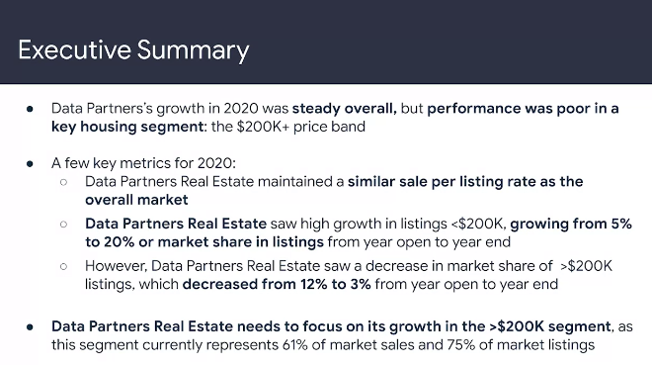
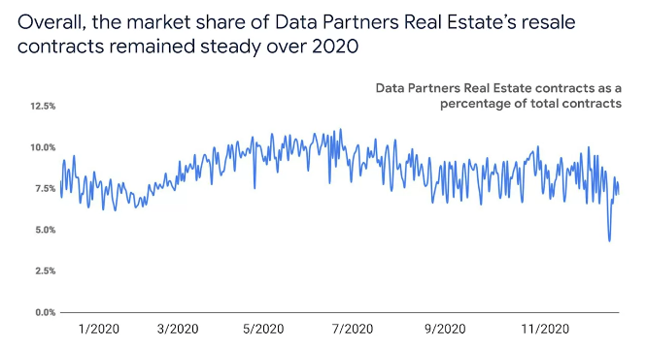
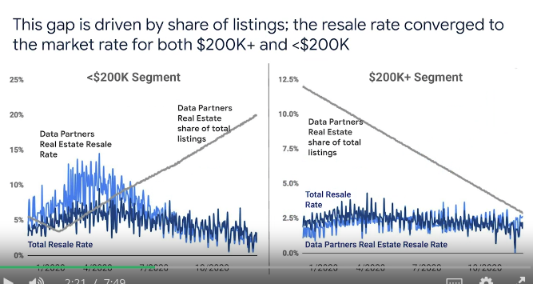
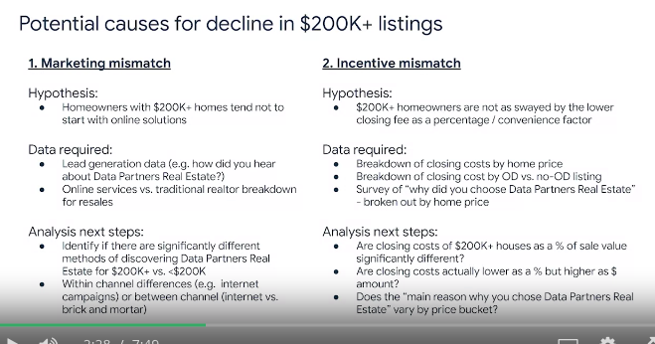
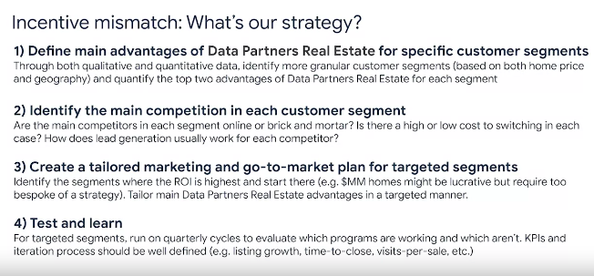

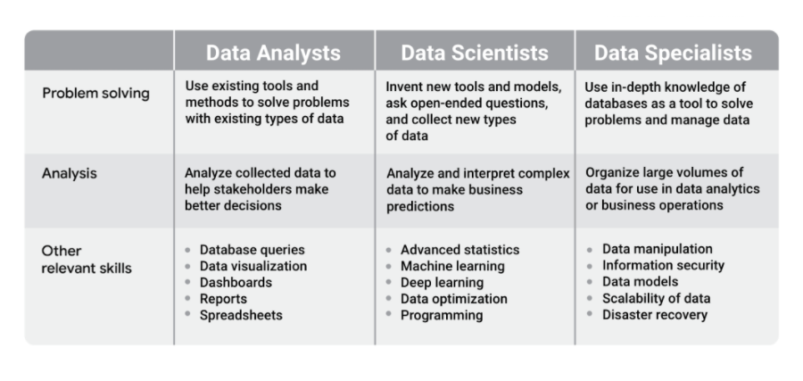

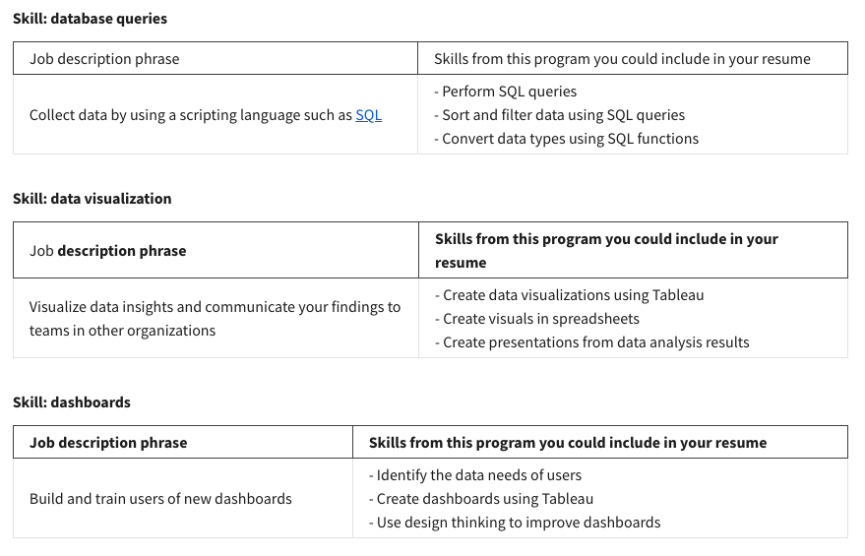
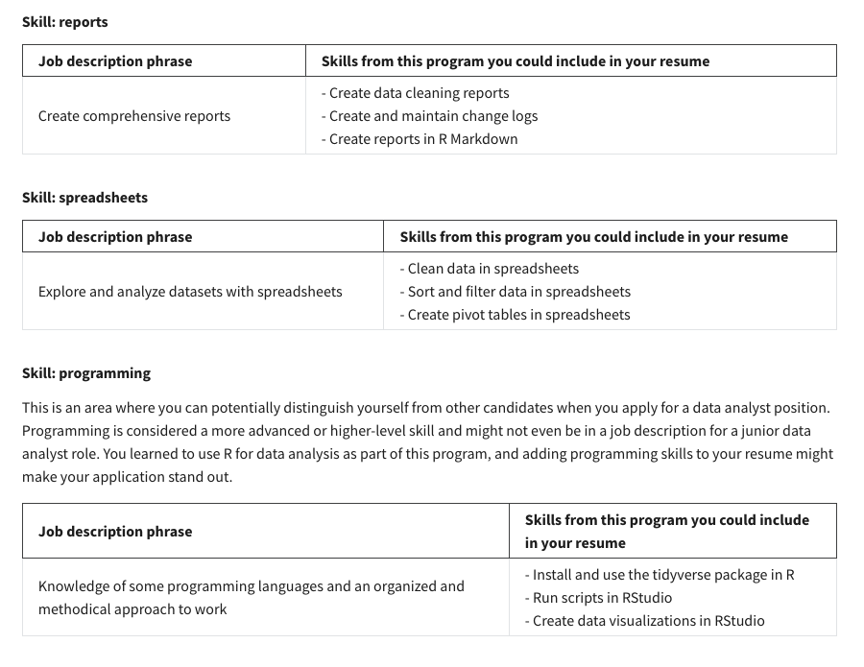
Key considerations of an elevator pitch include keeping it short, considering your audience’s interests, and focusing on your process. Practicing your elevator pitch is an important part of successful delivery.
This question gives you the opportunity to discuss the methods you use for error checking and validation as part of your data cycle process. In addition, you can point out that reliability and accuracy are essential parts of good data analysis and any issues with your data can have a major impact on data-driven business decisions. During an interview, it’s best to convey that you are proficient and eager to use all of the tools in the data analyst’s toolkit.
